

Attendance MS

TECHNO INDIA COLLEGE OF TECHNOLOGY

November 24, 2017

MInor Project

BCA 2015-2018



A Project Report for Minor project

Submitted by

Sourav Das

Ejaz Ahmed

Rima Biswas

Priyanka Roy



**BONAFIDE CERTIFICATE**

Certified that this project work was carried out under my supervision

***“Development* of a feature-rich, practical Online Attendance Management System”** is the bonfire work of

**Name of the student: Sourav Das Signature:**

**SIGNATURE**

Name : Bapi Tudu

**PROJECT MENTOR**

**Ardent Original Seal**



**BONAFIDE CERTIFICATE**

Certified that this project work was carried out under my supervision

***“Development* of a feature-rich, practical Online Attendance Management System”** is the bonfire work of

**Name of the student: Ejaz Ahmed Signature:**

**SIGNATURE**

Name : Bapi Tudu

**PROJECT MENTOR**

**Ardent Original Seal**



**BONAFIDE CERTIFICATE**

Certified that this project work was carried out under my supervision

***“Development* of a feature-rich, practical Online Attendance Management System”** is the bonfire work of

**Name of the student: Rima Biswas Signature:**

**SIGNATURE**

Name : Bapi Tudu

**PROJECT MENTOR**

**Ardent Original Seal**



**BONAFIDE CERTIFICATE**

Certified that this project work was carried out under my supervision

***“Development* of a feature-rich, practical Online Attendance Management System”** is the bonfire work of

**Name of the student: Priyanka Roy Signature:**

**SIGNATURE**

Name : Bapi Tudu

**PROJECT MENTOR**

**Ardent Original Seal**

**ACKNOWLEDGEMENT**

The satisfaction that accompanies with the successful completion of any task would be incomplete without the mention of people whose ceaseless cooperation made it possible, whose constant guidance and encouragements crown all efforts with success.

We are grateful to our project guide Prof. Tathagatha Barik and Bapi Tudu Sir for the guidance, inspiration, and constructive suggestions that help us in the preparation of this project.

Under his guidance, we have completed the challenging task in a very short time. He was involved throughout the entire project work, from the very beginning.

We are also grateful to all other teachers who have guided us in the development and completion of this project.

Finally, we would like to thank our family members for giving us inspiration and support for this “ONLINE ATTENDANCE MANAGEMENT SYSTEM” project work.

Date: - 24th Nov 2017

**GOALS AND OVERVIEW**

The ONLINE ATTENDANCE SYSTEM is developed to reap the benefits of internet along-with a regular task such as taking attendance as well as calculation of various statistic. It is designed for the benefit of both students and faculty in a campus.

We offer an Online Attendance System to automate the entire attendance-related work. This system is aimed at helping both the teachers and the students. The faculty members can make a personal account on this website after which he/she can customize their classes and take attendance as well each day. The students, on the other hand, can check their status directly from the website along-with a graphical display automatically generated.

d

**INTRODUCTION**

Online Attendance Management system is a software developed for daily student attendance in schools, colleges and institutes.

If facilitates to access the attendance information is sorted by the operators, which will be provided by the teacher for a particular class. This system will also help in evaluating attendance eligibility criteria of a student.

Minor Project(TICT)  
Attendance MS

November 24, 2017

## Project Background and Description

Project Name: Attendance MS

Description:

It is and Online Automated Attendance Management System for schools and colleges.

It is aim to automate the huge redundancy in attendance counting.

Team Members:

1. Sourav Das – 31401215050
   1. Server
   2. Back End
   3. Database
2. Ejaz Ahmed – 31401215017
   1. Front End
   2. UI Design
3. Rima Biswas – 31401215037
   * 1. Documentation
4. Priyanka Roy – 31401215032
   * 1. Presentation

# REQUIREMENTS

## Software Requirement Specification

## Client Requirement

* 1. The system in use should automatically update each data pertaining to a student’s attendance or a faculty member.
  2. It should require minimum technical attention to operate properly as attendance would be taken on a daily basis.
  3. Calculations can be done automatically.
  4. It should be able to hold data for a minimum of 10000 students and faculty member at a time.
  5. The database should be made such that minimum space is required without the need of keeping any back -up.
  6. All Faculty should be able to see all subjects and take attendance of any class.
  7. The Faculty who has taken the class has permission to be able to make changes to that class or the Administrator.
  8. The project should have the following views:
     1. Faculty wise - Subject wise class count.
     2. Student wise – Subject wise Attendance Percent and Count
     3. All Classes Taken by the Faculty
     4. Student wise – Class date wise Attendance Markings

## Project Requirement

* The project to be developed requires continuous internet connectivity with a minimum speed.
* A Standard Desktop or Laptop.
* A local Apache with MySQL server on the developing system.
* A normal text editor and a web browser.

## Technical Requirements

* User

1. The system can operate using the internet on any device- smartphone screen or desktop screen.
2. Internet used should be of 2G 3G 4G speed for the system to operate fully functionally.

* System

1. The response time and through-put periods shall take a maximum of 30 seconds with any number of users simultaneously.

## Functional Requirement

* Required Features
  1. Automatic upload of data using internet.
  2. Member log-in facility.
  3. Maximum security to prevent discrepancy in data.
  4. All data should be stored online without a need for back up.
  5. Automatic calculations of statistics.
  6. Auto-refresh facility after completion of each semester.
* Optional Features
  1. Student access to view individual data.
  2. Graphical display of student data.
* Security Features
  1. The system will provide each faculty members with a ID and a password to log in .
  2. The data of one member will not be displayed with the data of another member.
  3. It shall restrict access to functions to authorized group and class of users.
  4. It shall provide a mechanism to distinguish between the inquiry and update capabilities of each of the user class.
  5. The system must have at least 2 user group:
     1. Administrator
     2. Normal User

## 3.Project Overview

* **Purpose**

Attendance MS is developed to reap the benefits of internet along-with a regular task such as taking attendance as well as calculation of various statistic. It is designed for the benefit of both students and faculty in a campus.

We offer an Online Attendance System to automate the entire attendance-related work. This system is aimed at helping both the teachers and the students. The faculty members can make a personal account on this website after which he/she can customize their classes and take attendance as well each day. The students, on the other hand, can check their status directly from the website along-with a graphical display automatically generated.

We believe that this system would bring uniformity and reduce a lot of manual effort. There would be no need of maintaining heaps of physical data. Faculty would find it comforting to access their daily chores on-the-go as well as view the entire session at the end each of term. Students would be more aware of their attendance status in each class and therefore would be more cautious in maintaining the requirements.

* **Scope**

1. This system has potential of automating office work and reducing work load thereof.
2. It will take up minimum space for maintaining database.
3. It will also provide a database back up of 12 years.
4. It provides absolute security with the use of a log-in id and password for faculty.
5. It will help students to view their attendance status and maintain transparency.

* **Technical Constrains**
* **User**
  + 1. The user should have either a smartphone or a desktop with continuous internet connectivity.
    2. They should also have a minimum knowledge of handling internet related activity.
    3. A web browser with JavaScript, Css3 and Html5.
  + **System**
    1. A web server with Php and MySQL.
    2. 5,000 MB bandwidths.
    3. 500 MB Storage.
    4. Smtp Server.
    5. Ftp Support.
  + **Third party software constraints**
    1. Php Laravel web framework
    2. Bootstrap
    3. Materialize CSS
    4. jQuery

# Software Project Management Plan

1. **Deliverables.**

|  |  |  |
| --- | --- | --- |
| Phase | Deliverables | Due Date |
| Initial Structuring | * SDLC Finalization * Constrain List * Requirement List | 2 Sep 2017 |
| Initial Structuring (phase 2) | * Database Design * Class Design * Basic UI Layout | 15 Sep 2017 |
| Phase 1 | * Environment Setup * Tools Finalizations * Team Organization | 20 Sep 2017 |
| Phase 2 | * Feature by Feature Deployment * Design Feature * Implement Feature * Test Feature * Client Feedback | 20 Oct 2017 |
| Phase 3 | * Finalizing Edits * Re-Design Feedback * Implement and Test Redesign | 20 Nov 2017 |
| Phase 4 | * Uploading to Server * Configuring Server * Mandating Security * Client Feedback | 25 Nov 2017 |

1. **Implementation Plan**
   1. **Team Organization**
      * Sourav Das
      * Ejaz Ahmed
   2. **Environment Finalization**
      * Server: Apache
      * Server-Side Scripting: Php
      * Database: MySQL
      * Web Framework: Laravel
      * Client-Side Scripting: JavaScript
      * Supporting Software:
        1. jQuery
        2. Bootstrap
        3. Materialize CSS
        4. CSV plugin
   3. **SDLC Model Finalization**

The Project will be developed using the Iterative Model

All Iteration will design, Implement and Test some feature at a time.

* 1. **Incremental Stage/Phase Plan**
     + 1. Stage – 1 (Initial Structure)
          1. Basic Attendance taking and viewing functionality.
          2. 4-page website.
       2. Stage – 2 (Iteration 2)
          1. User Login and Admin Settings
          2. 16-page website
       3. Stage – 3 (Iteration 3)
          1. Attendance View for Student
          2. 20 – page website.
       4. Stage – 4 (Iteration 4)
          1. Security and Long-Term Data Saving feature.
          2. 32-page website.

1. **Project Process**
   1. **Designing**

* Database Design
  1. Assumed Constraints
     1. Subjects change after each semester.
     2. Only one batch for a particular department-year is present
     3. A semester has a length of 156-185 days.

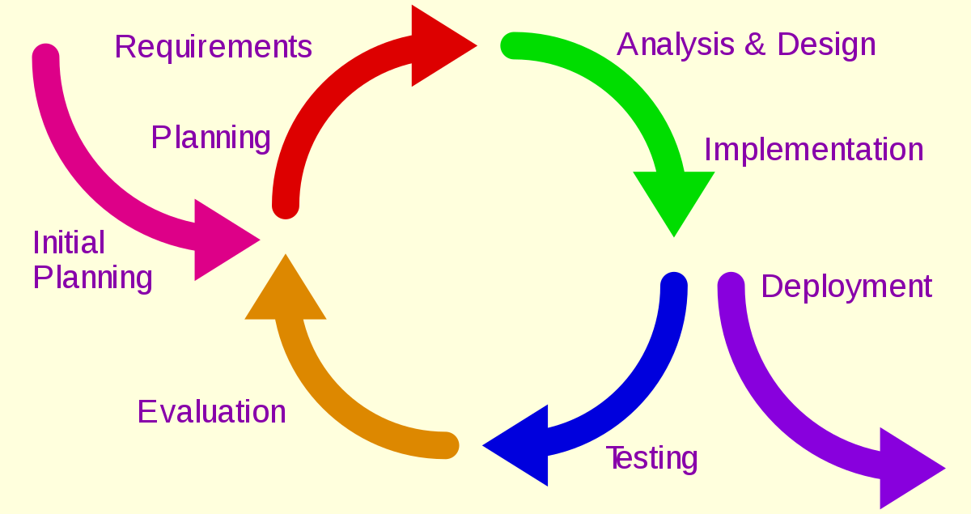

* **E**ntity **R**elationship **D**iagram:

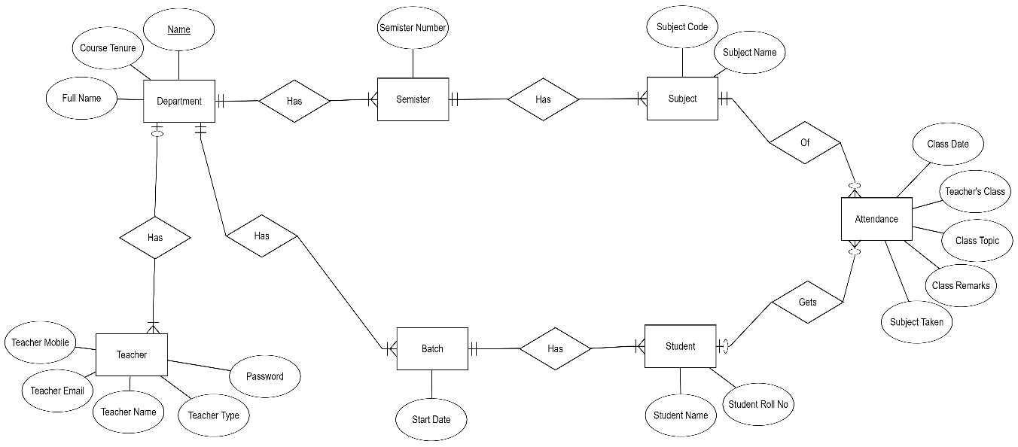

* **Table Design**

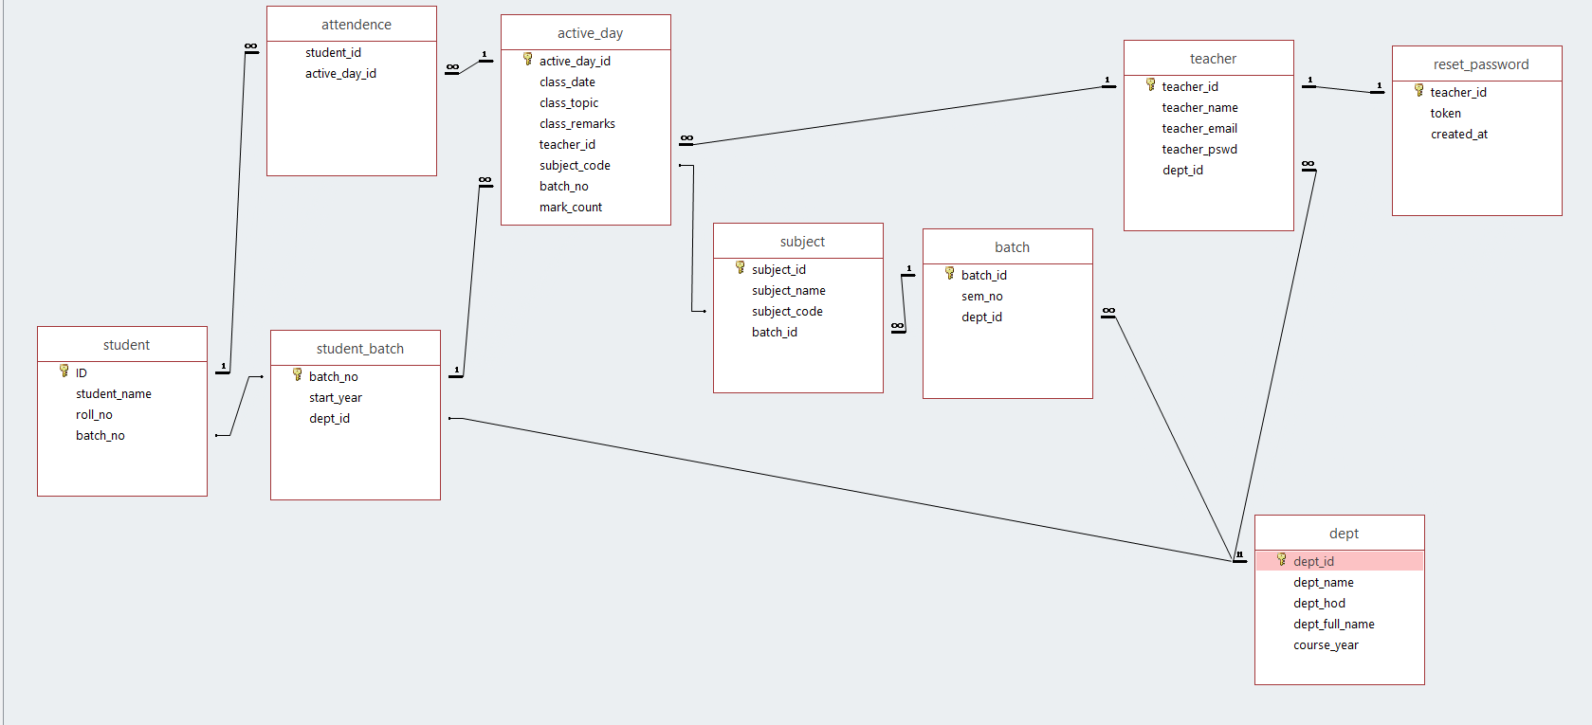

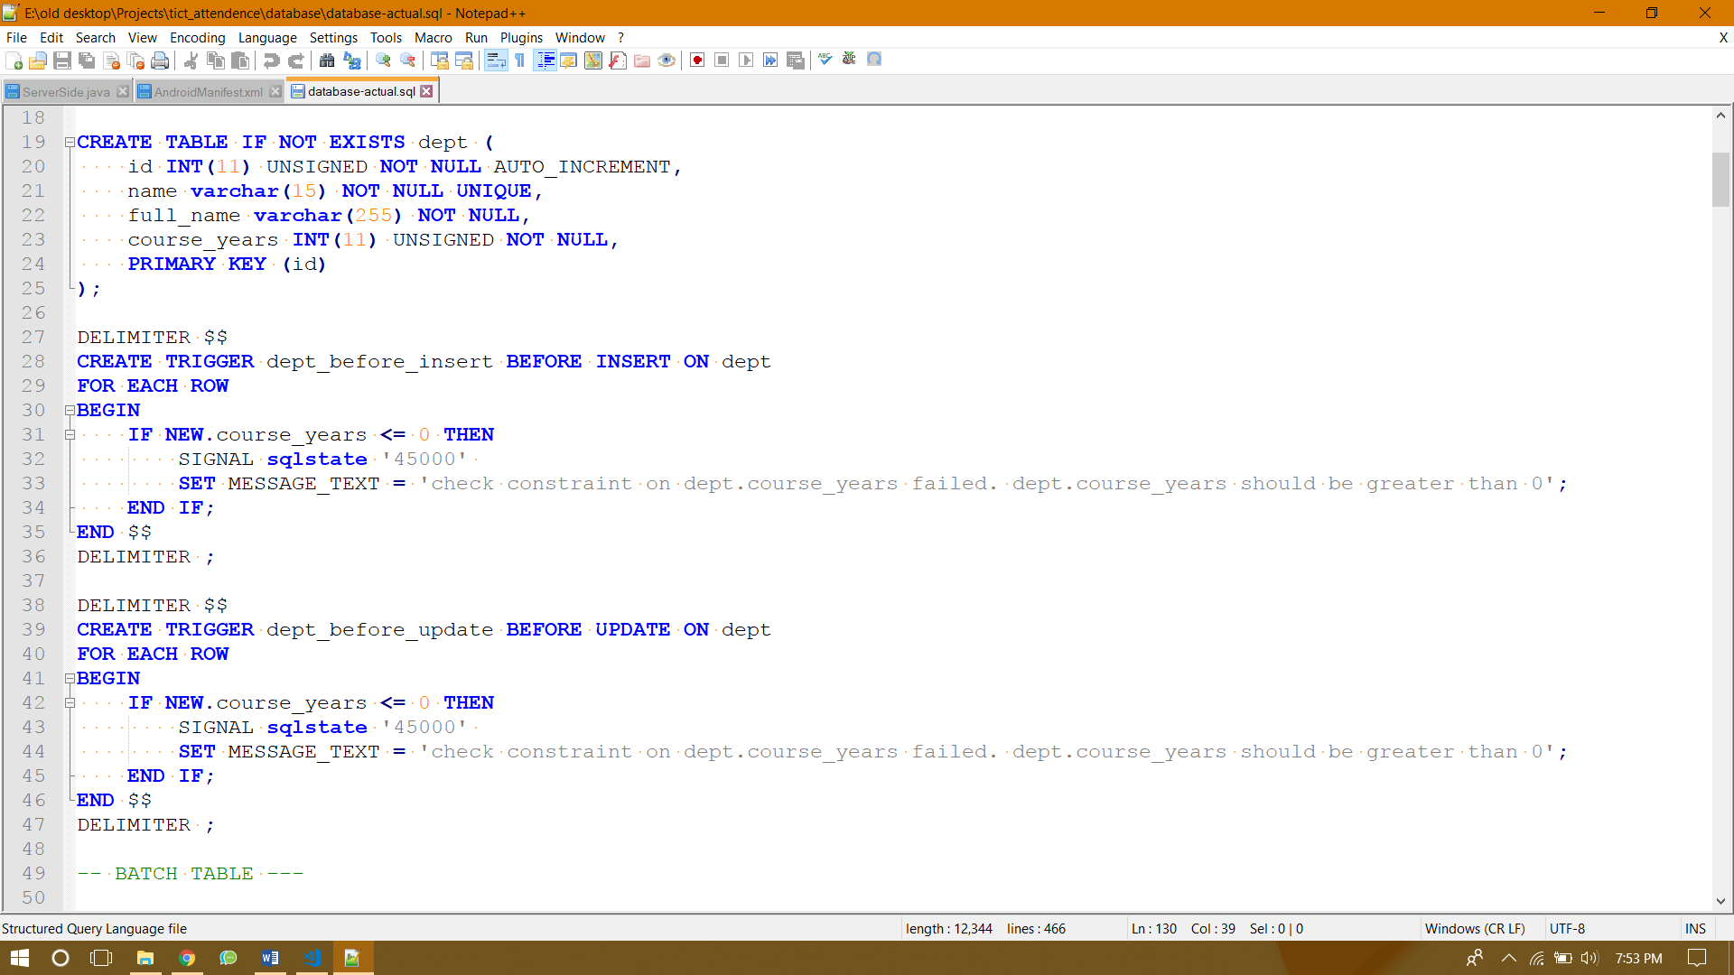

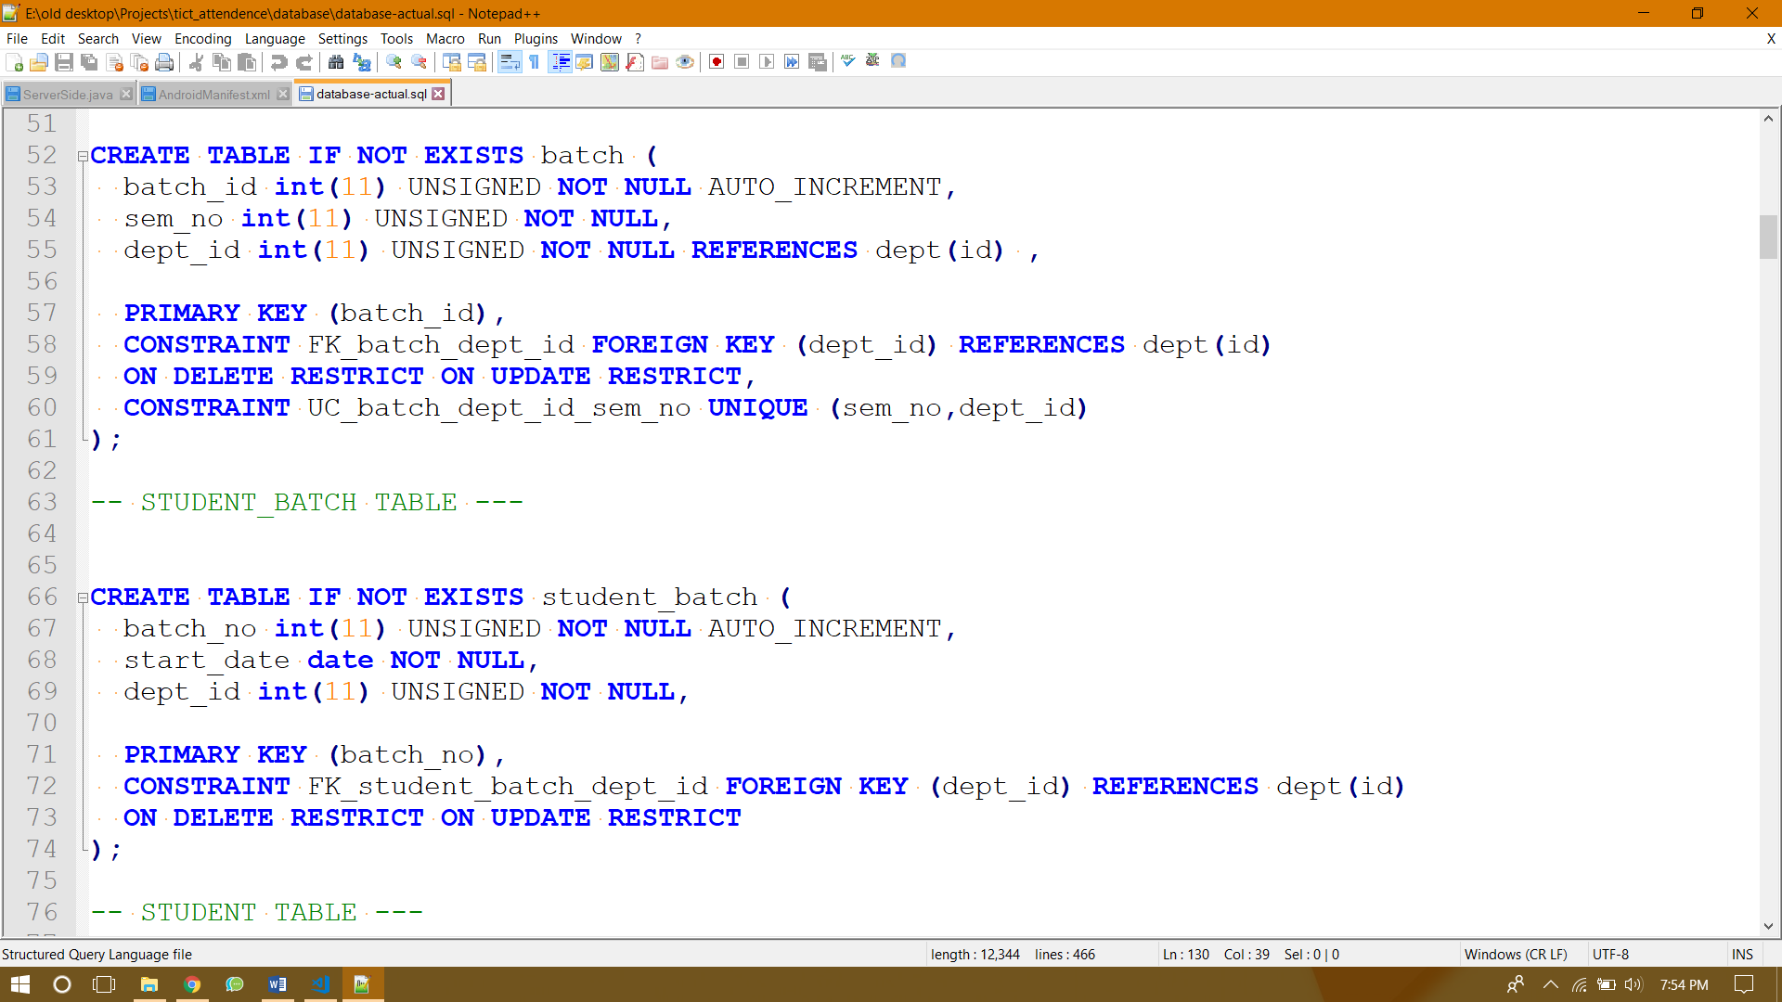

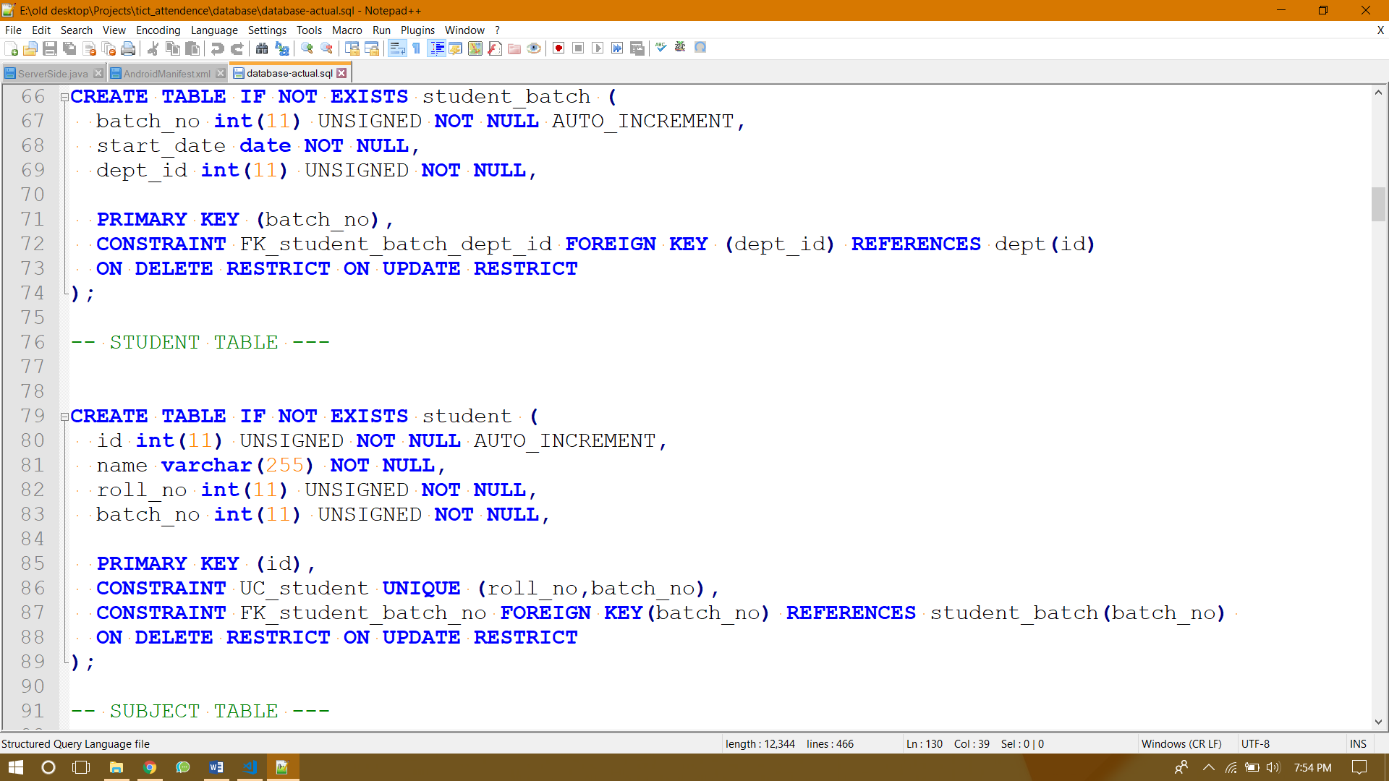

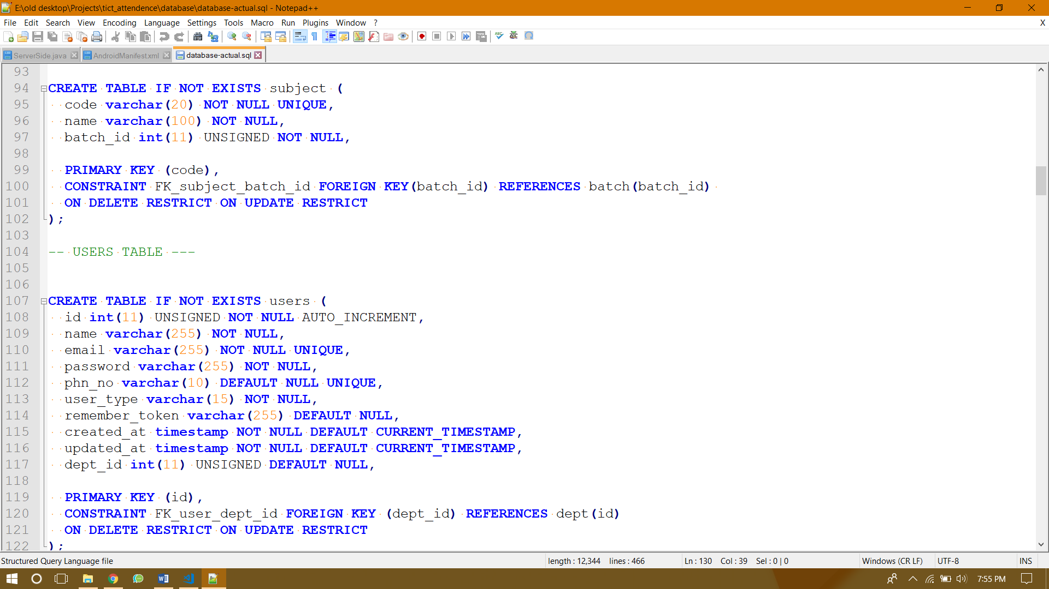

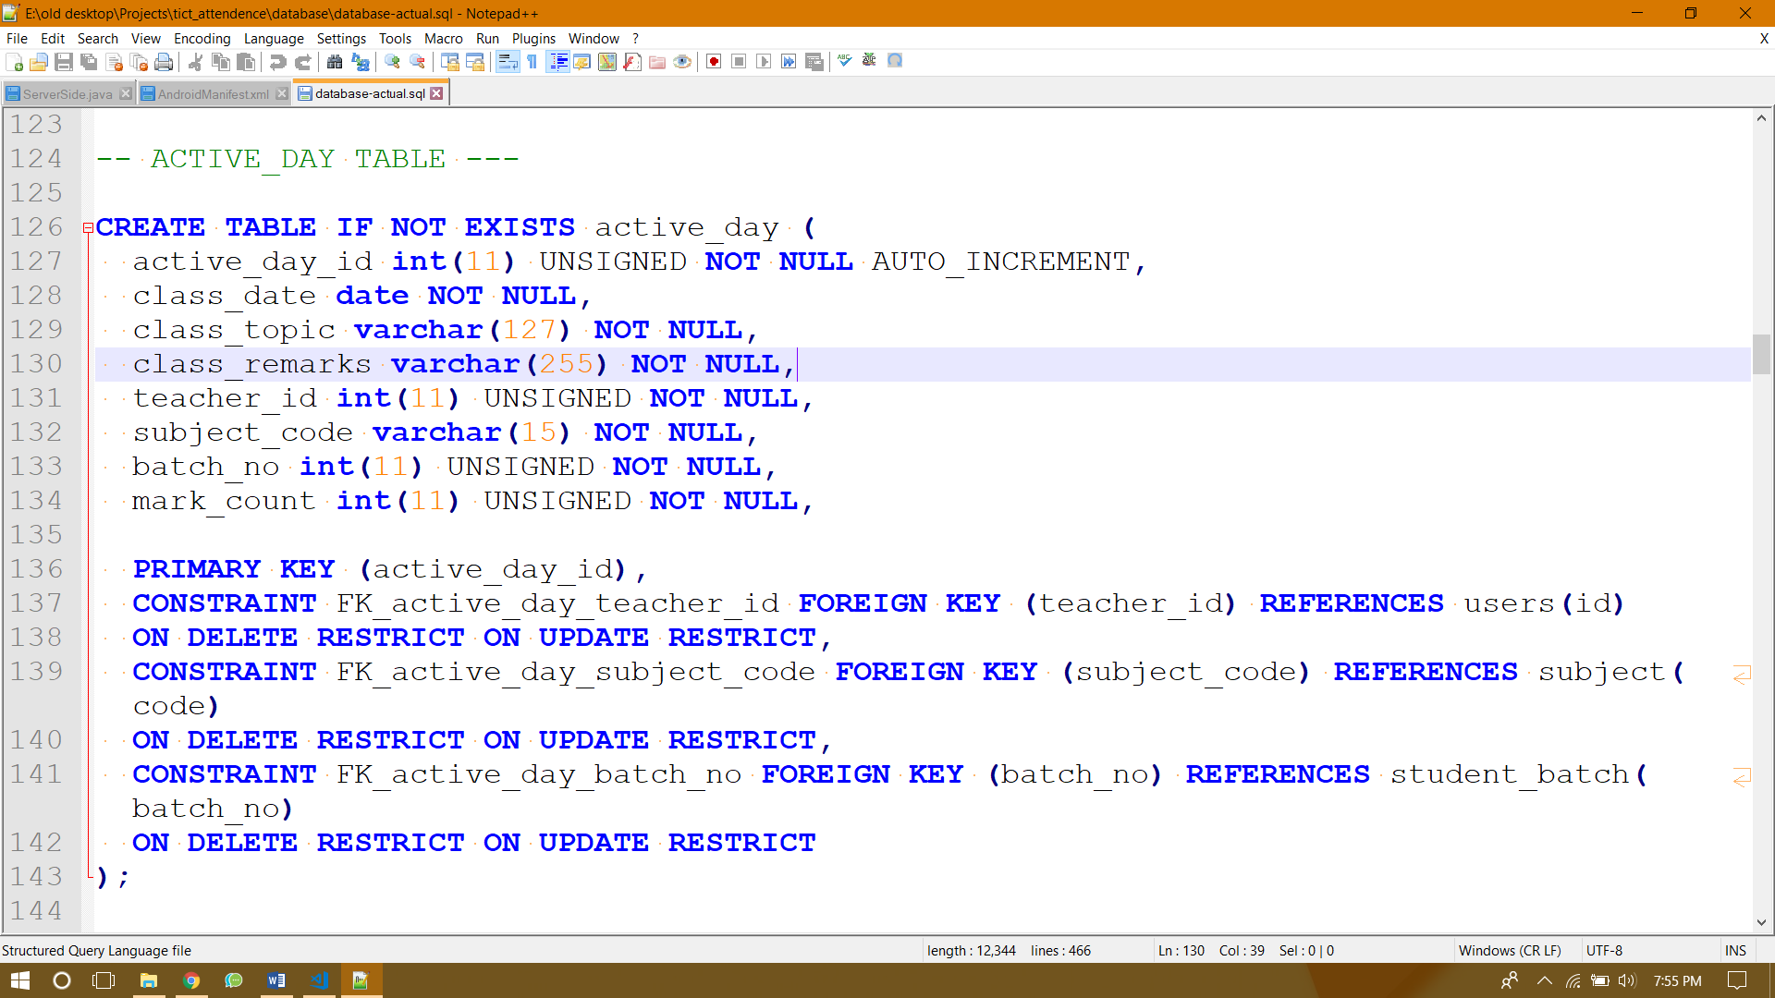

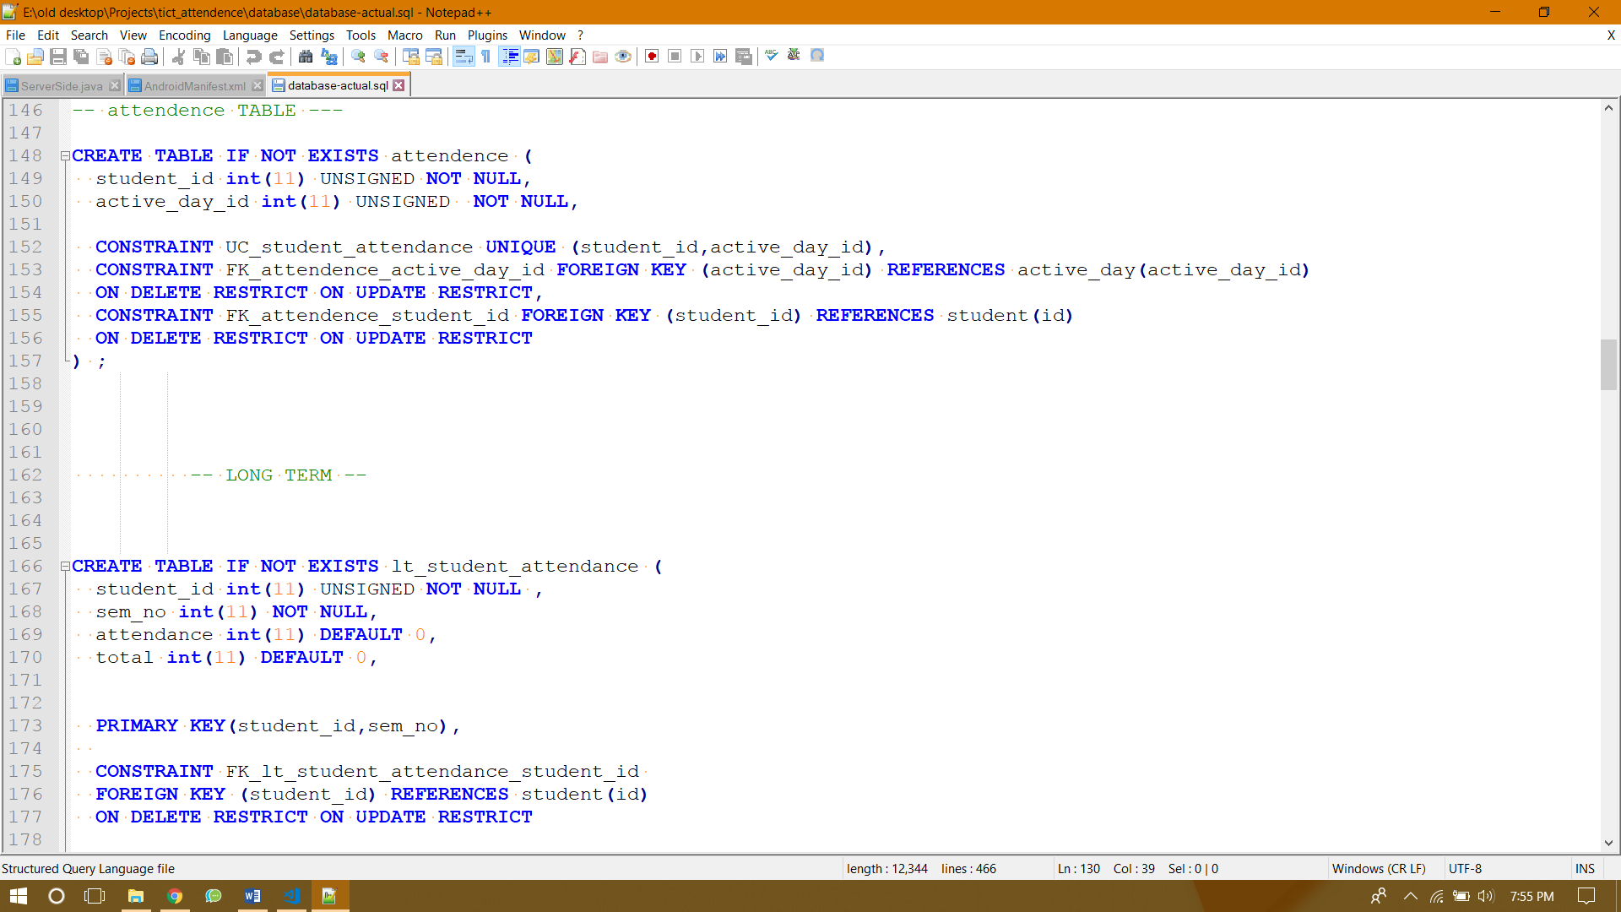

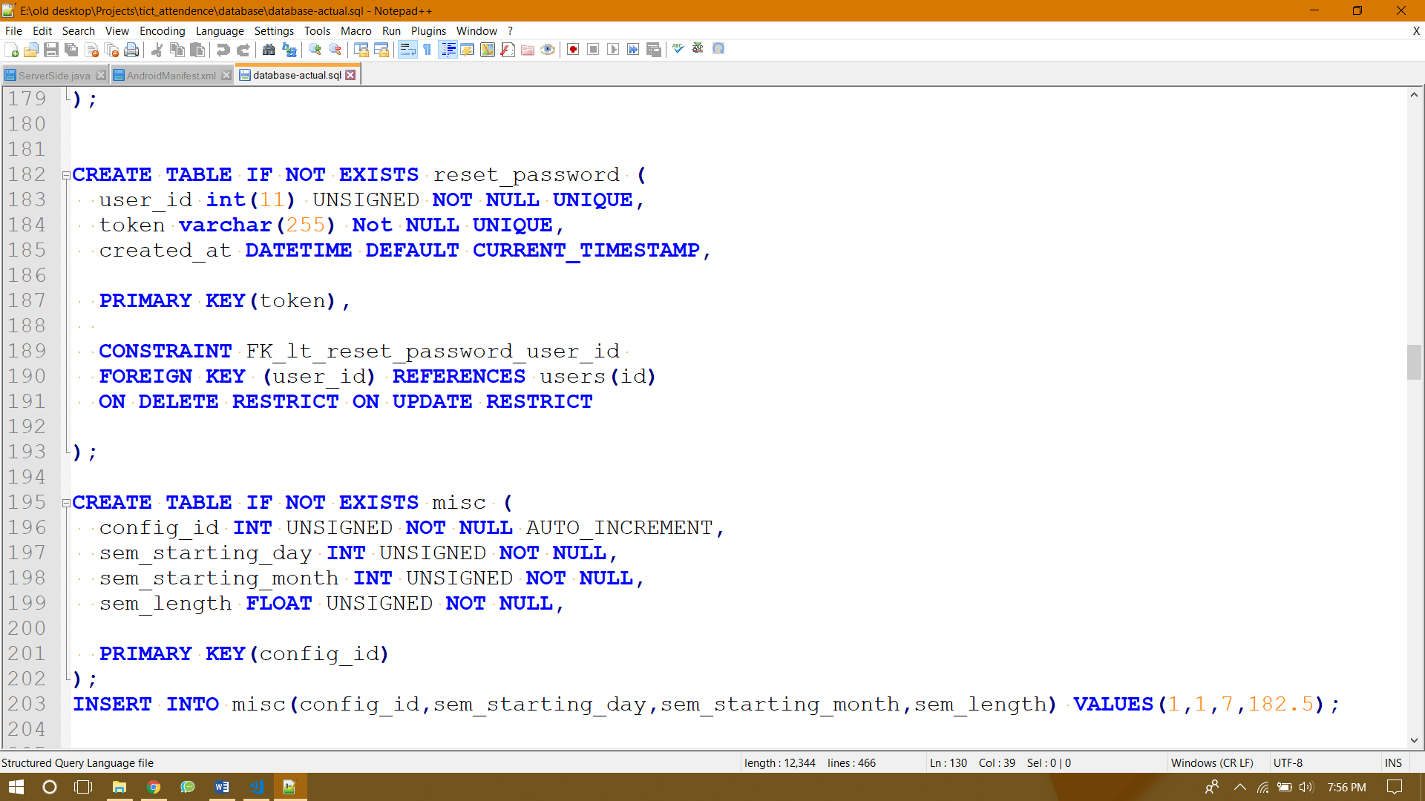

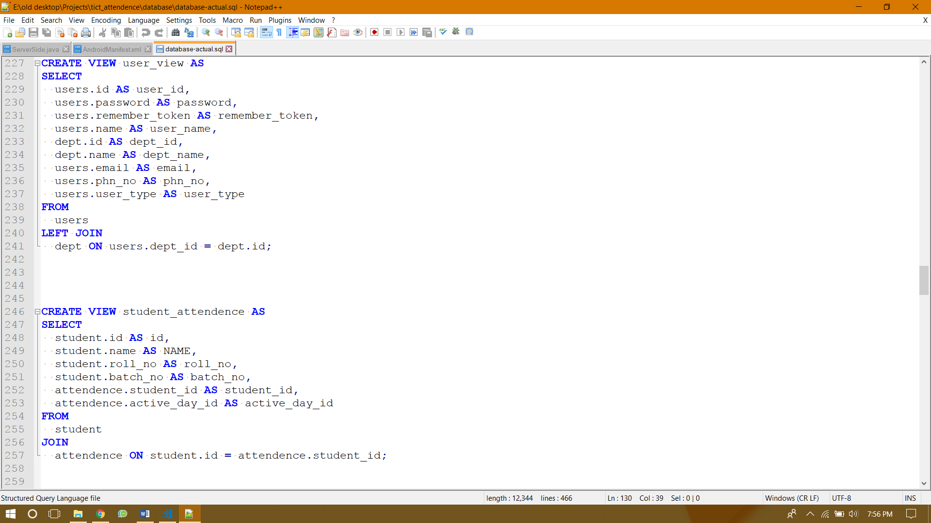

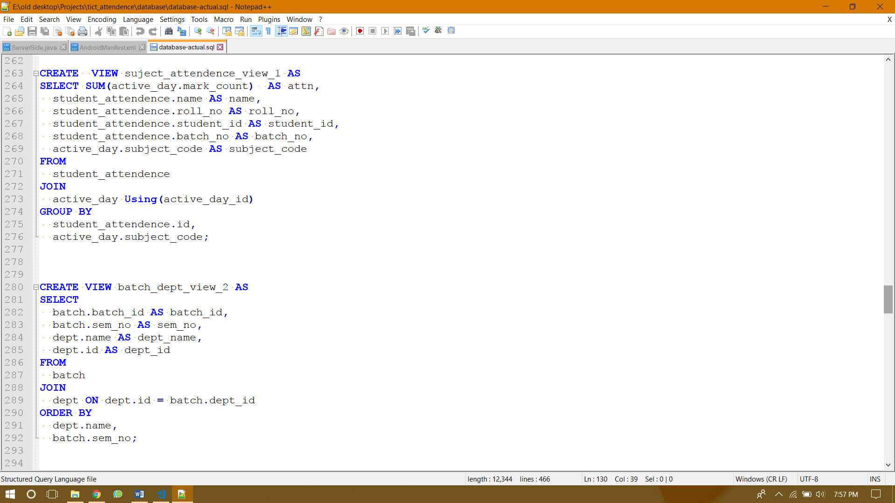

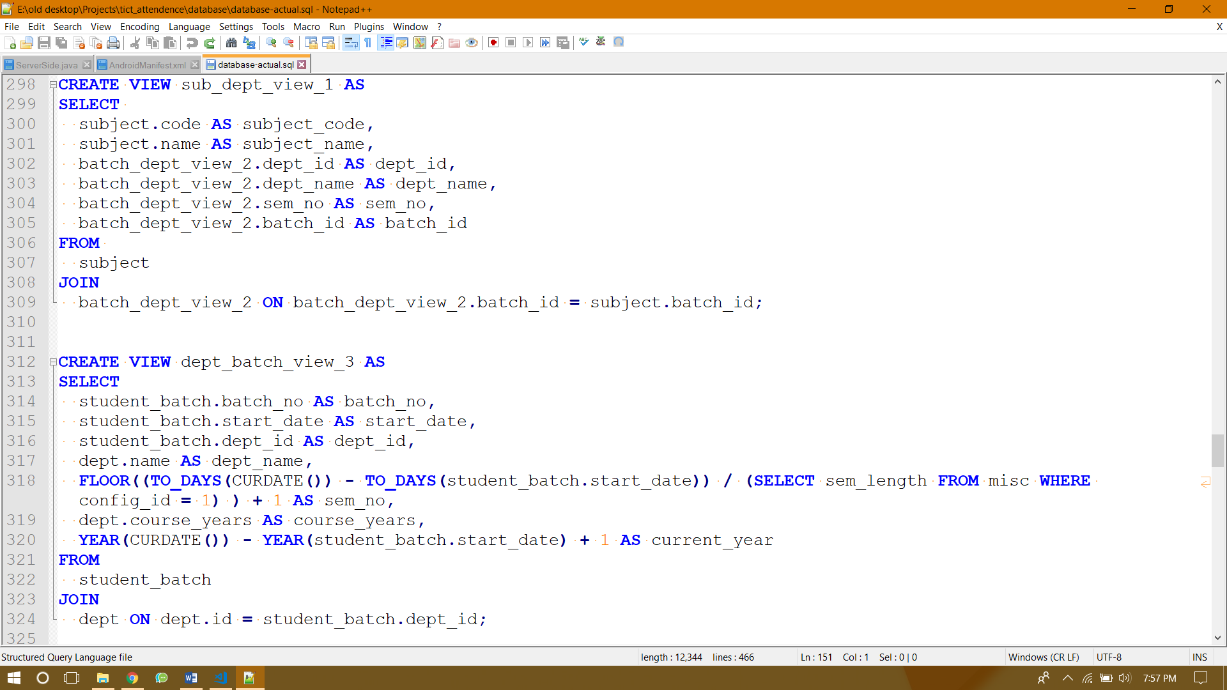

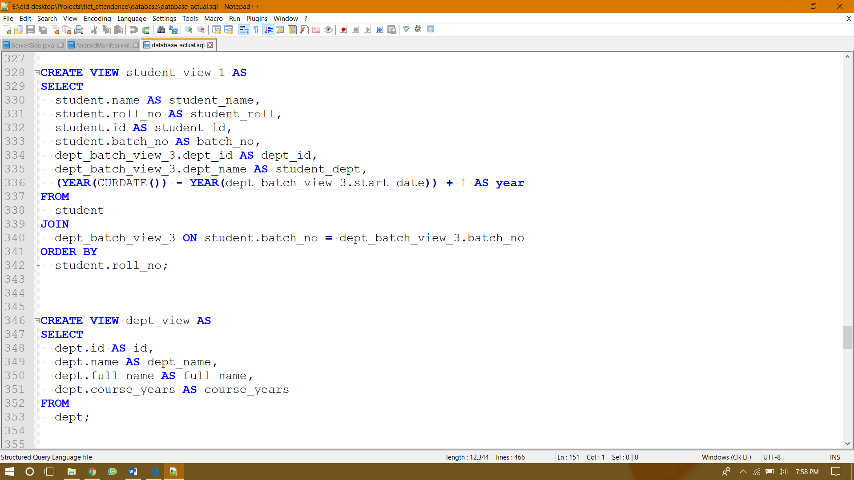

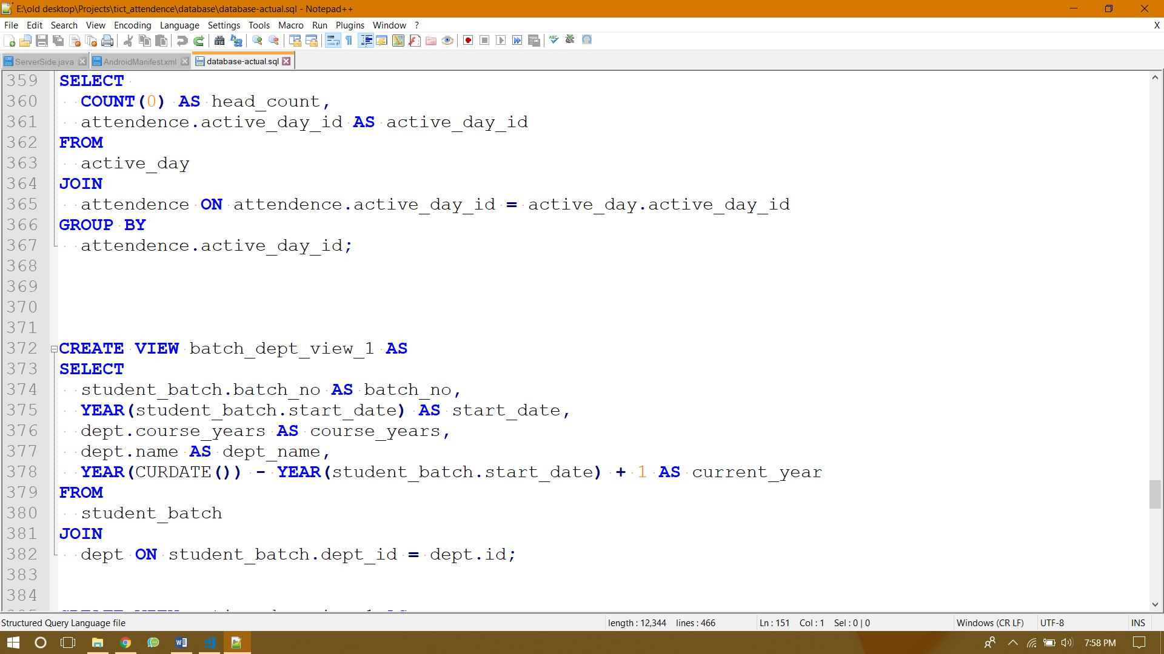

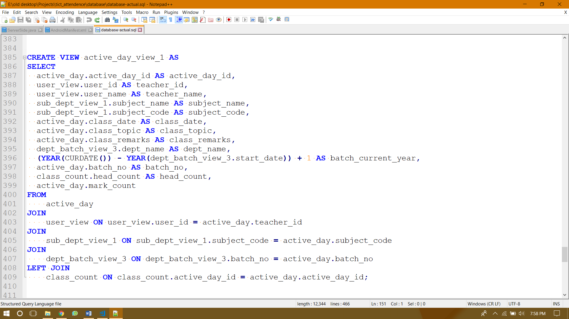

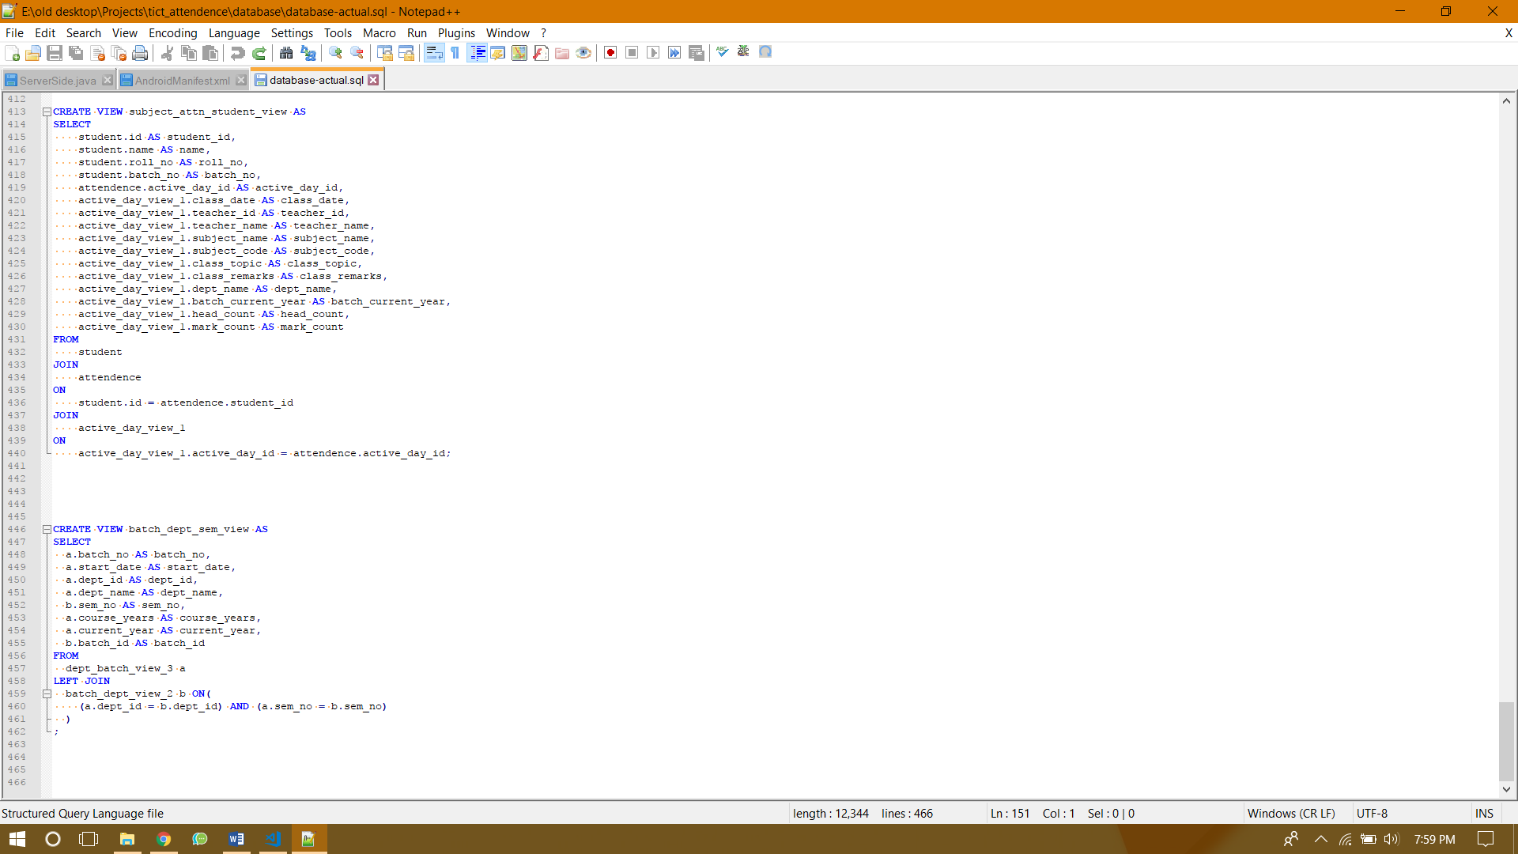

Interface Design

User Interface Design

# Feature Design (website)

## Home Page

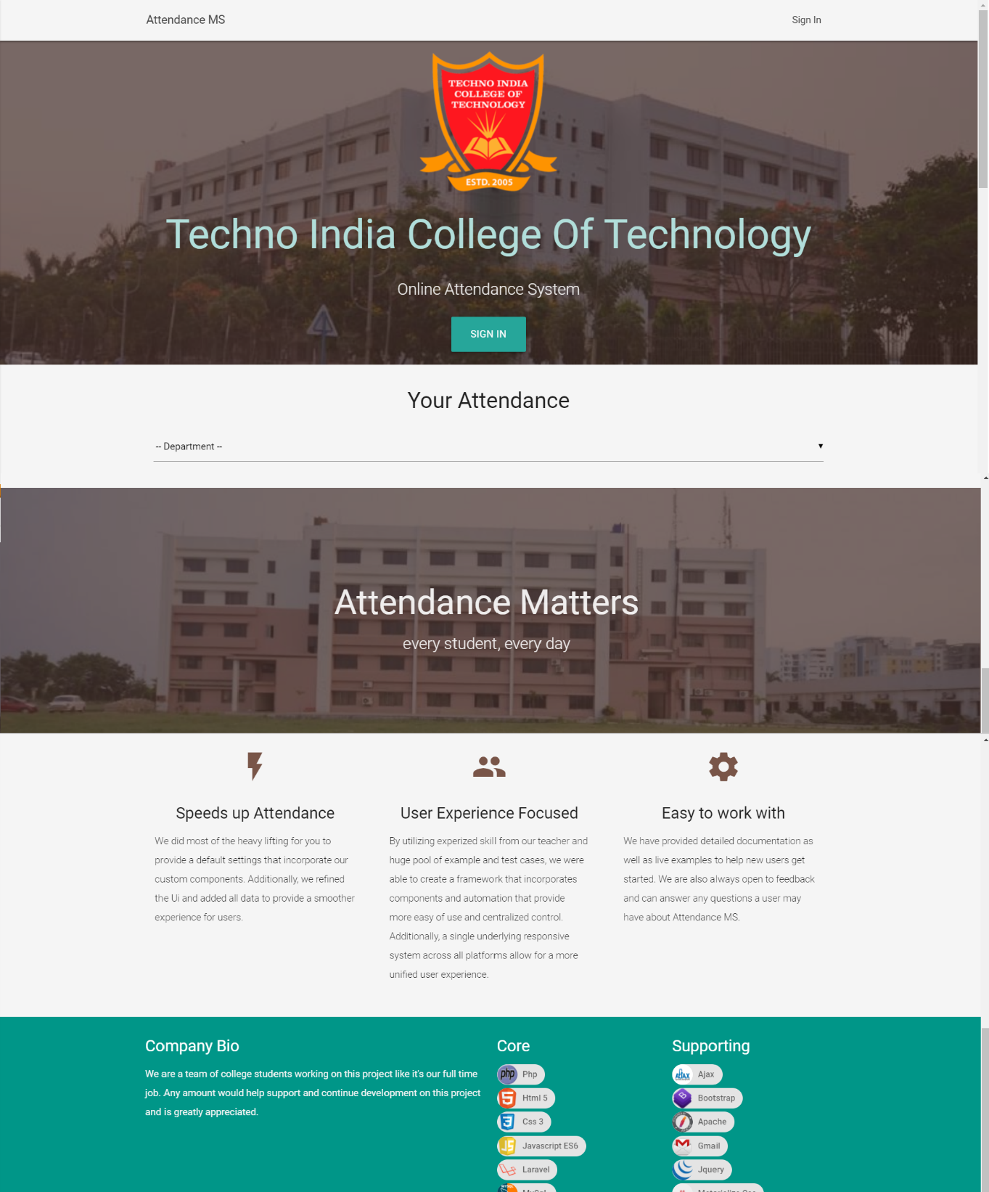

## Sign In

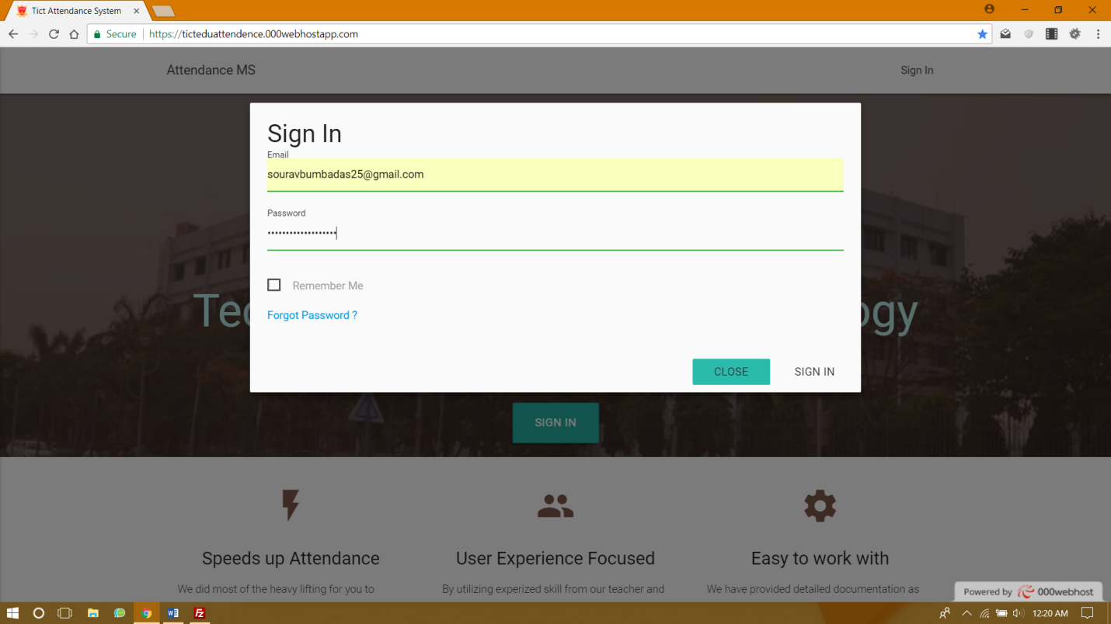

## Attendance View for Student

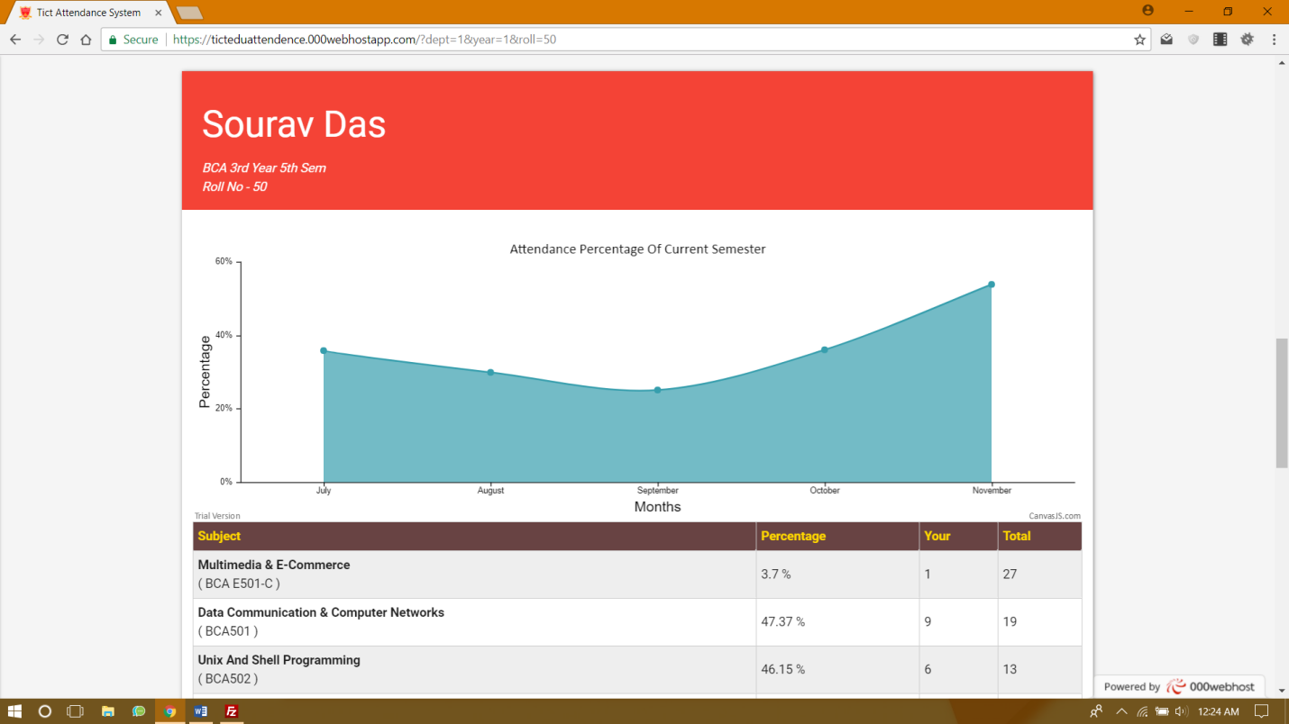

## Dashboard

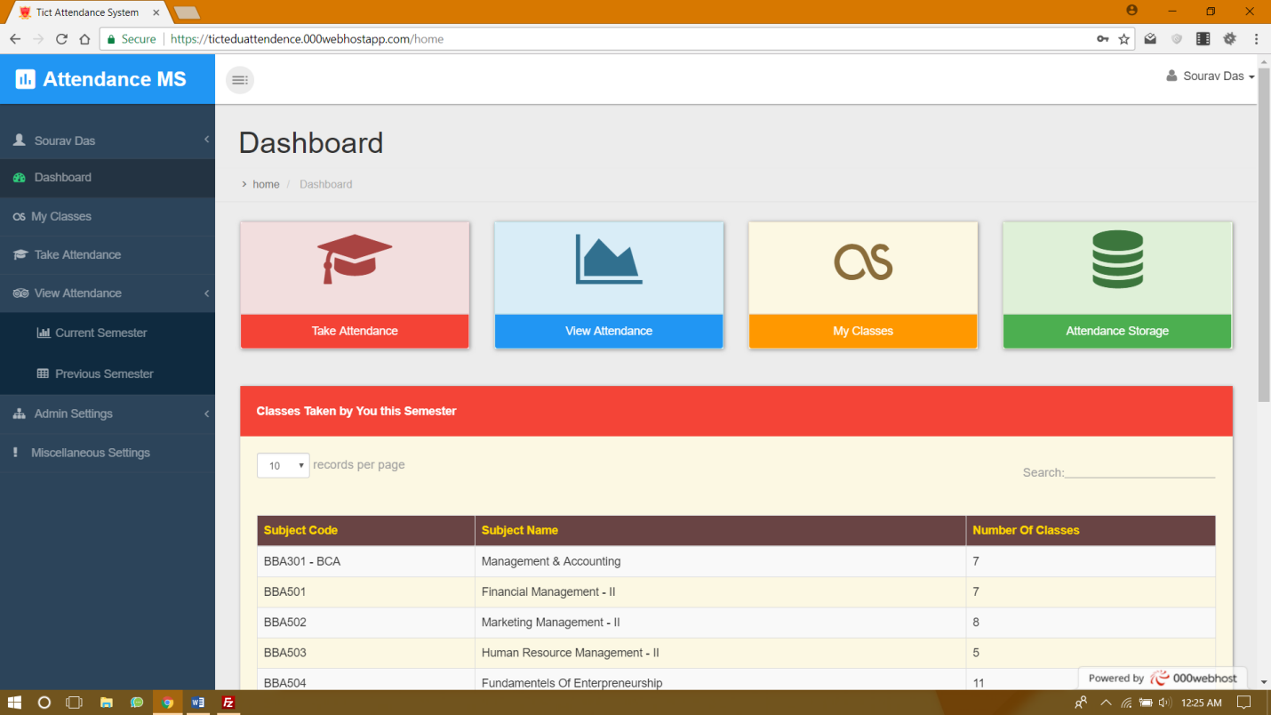

## 

## Take Attendance

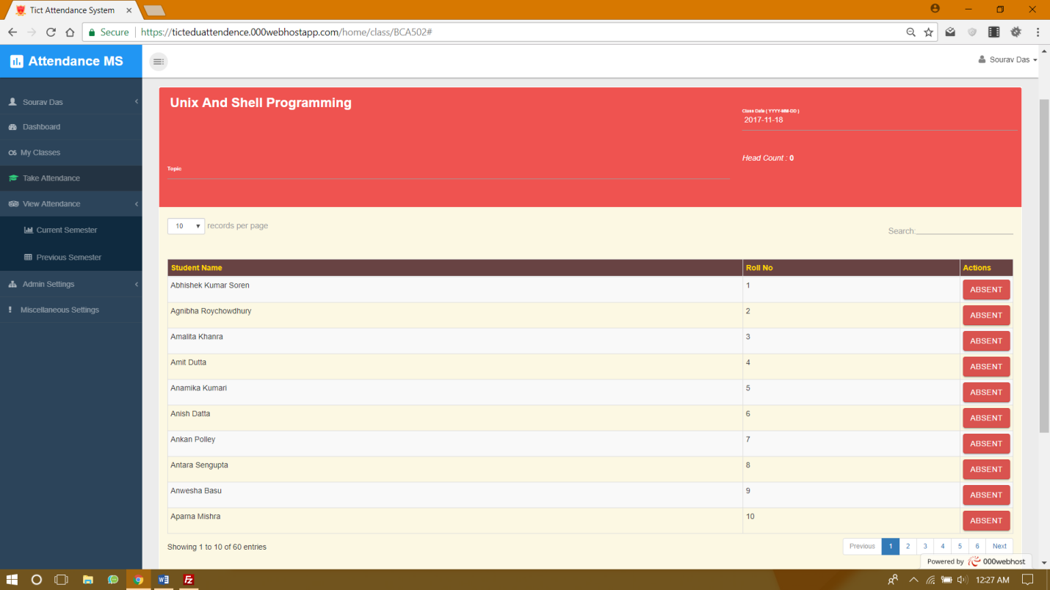

## Current Semester Attendance Viewing

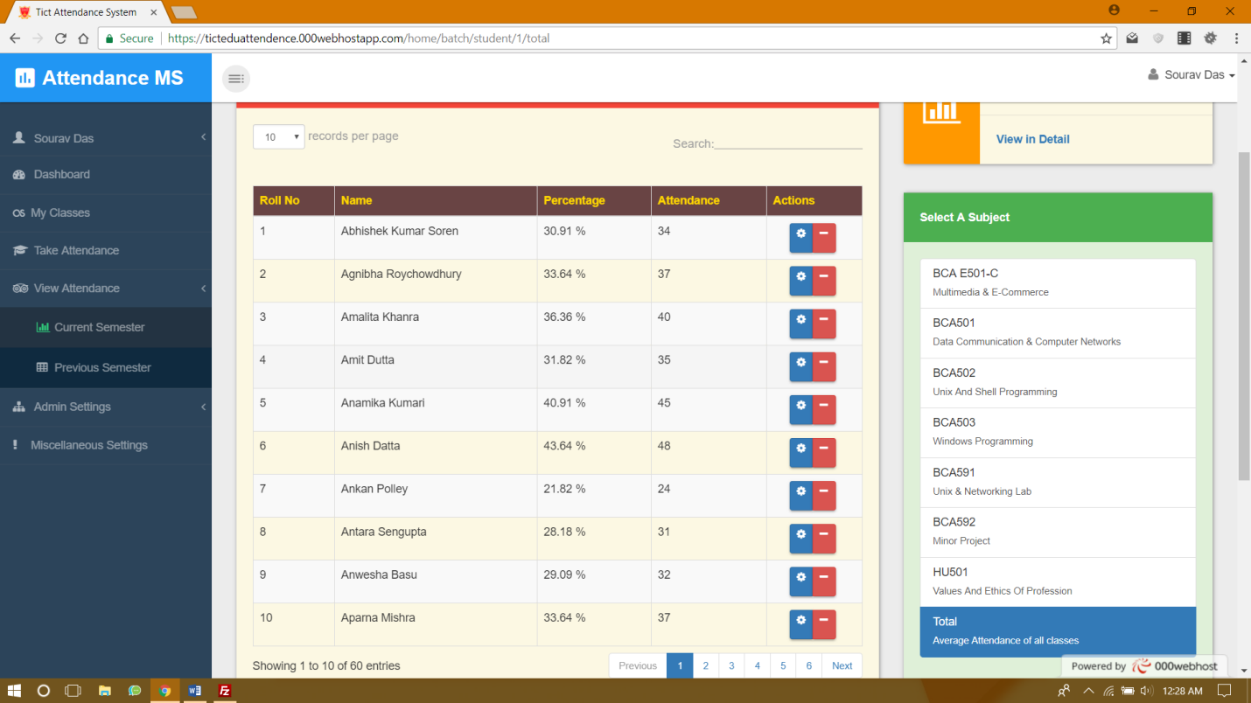

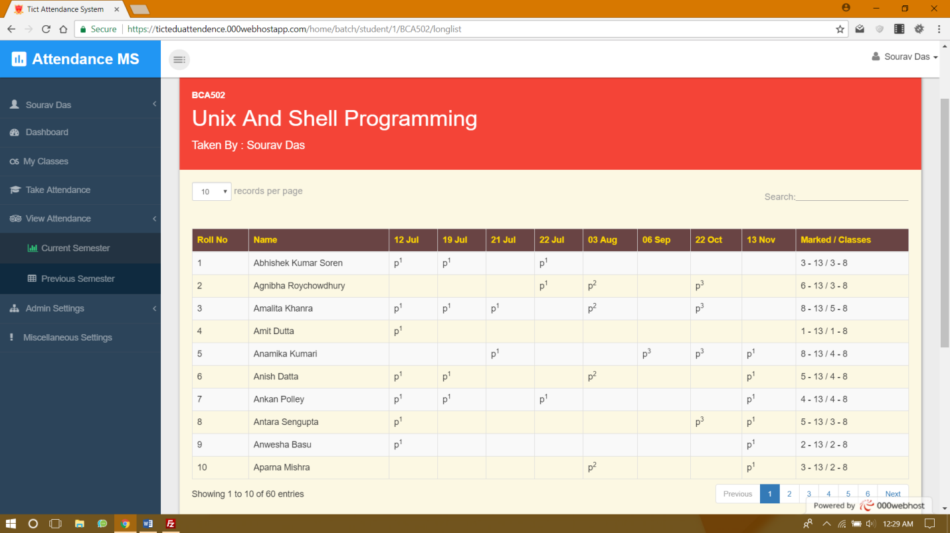

## Previous Semester Attendance Viewing

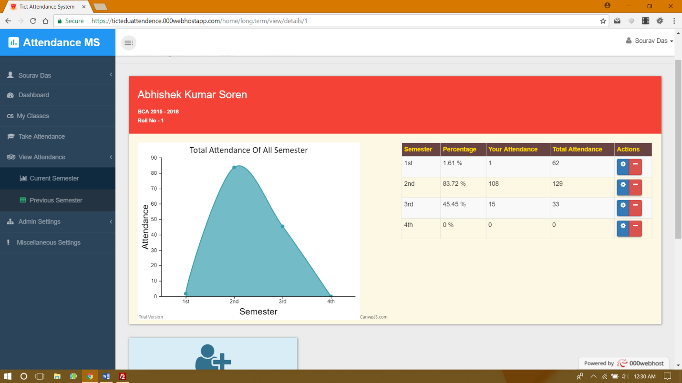

## Admin Settings

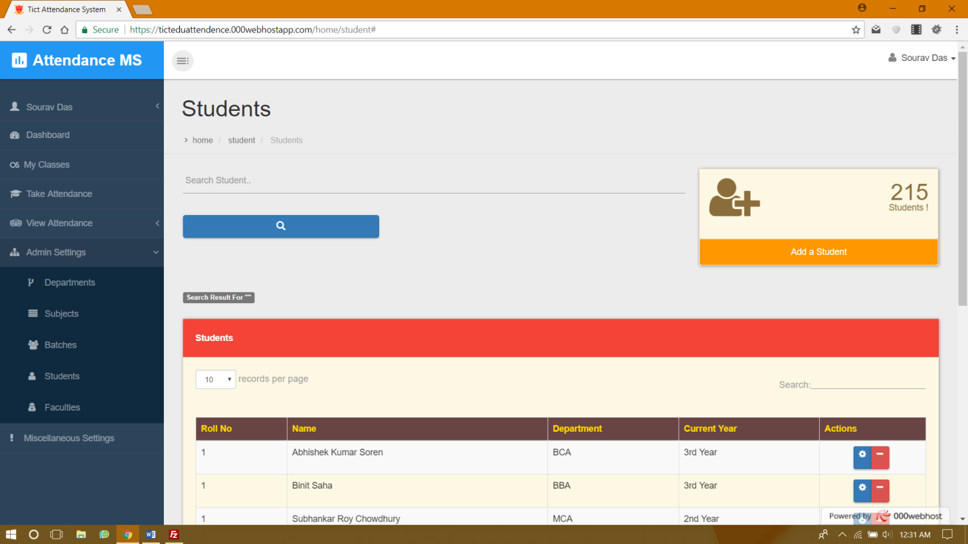

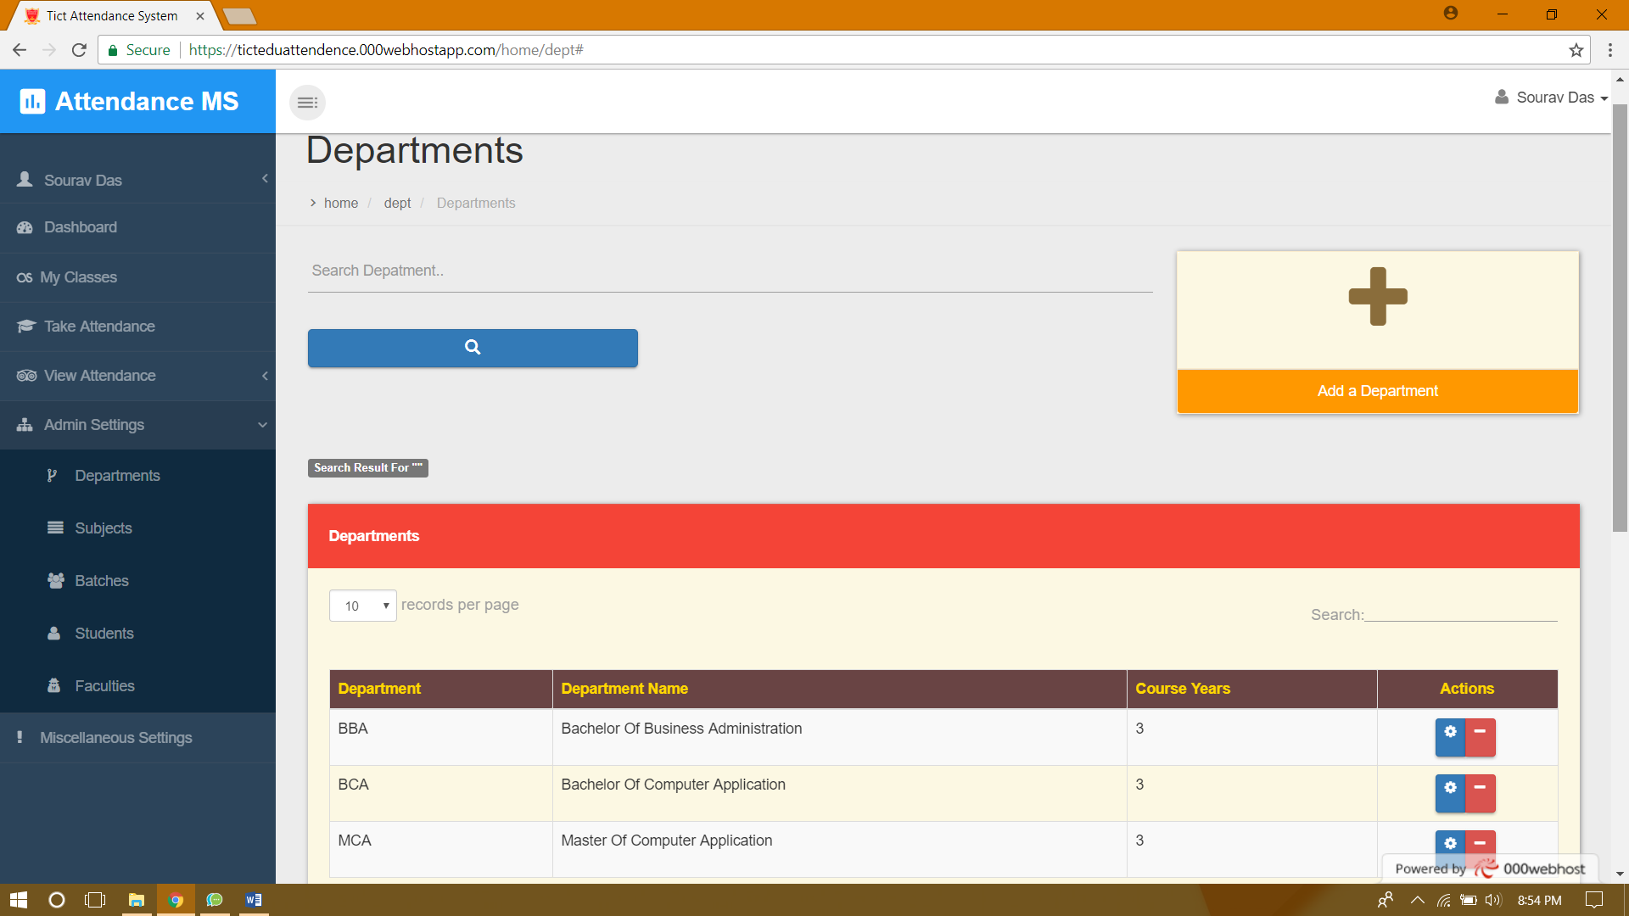

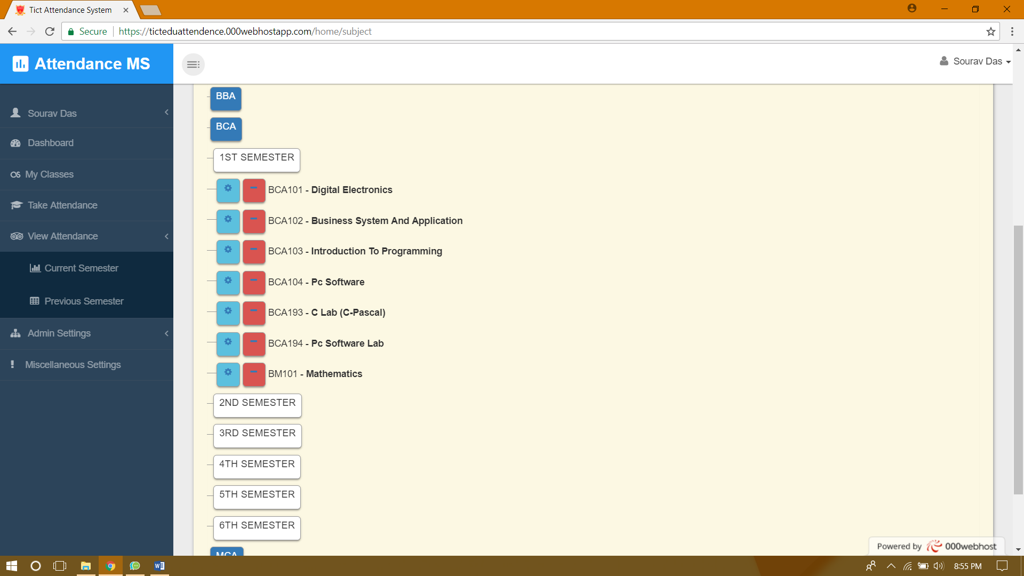

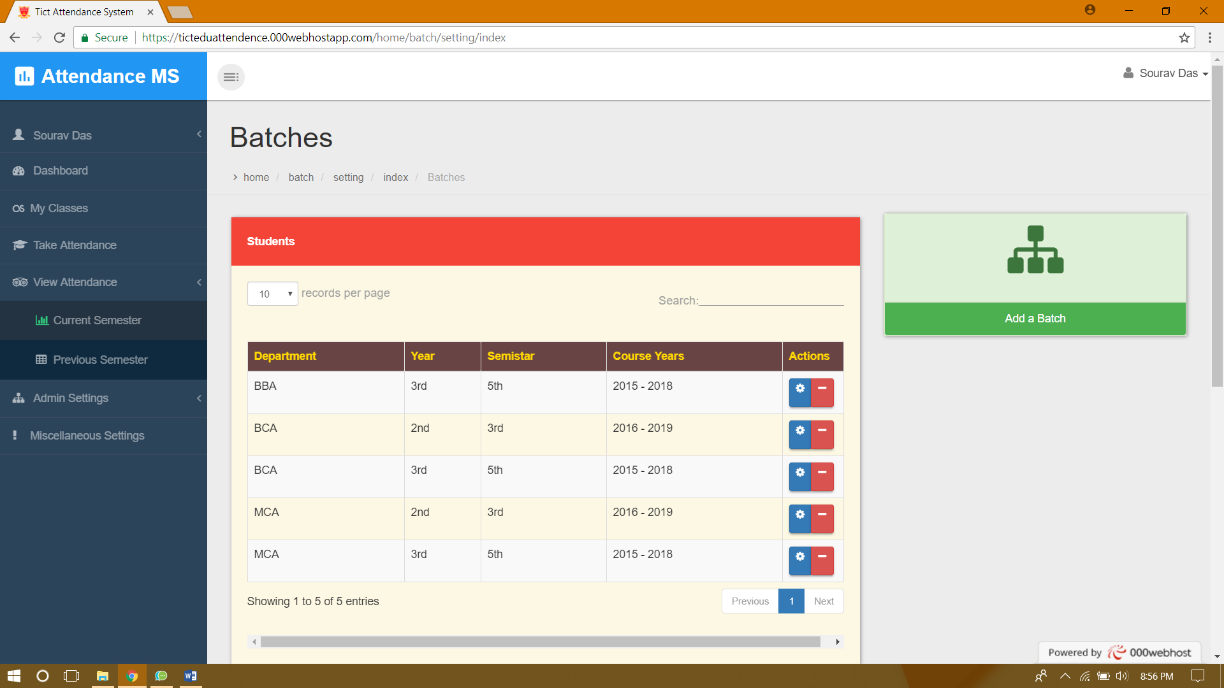

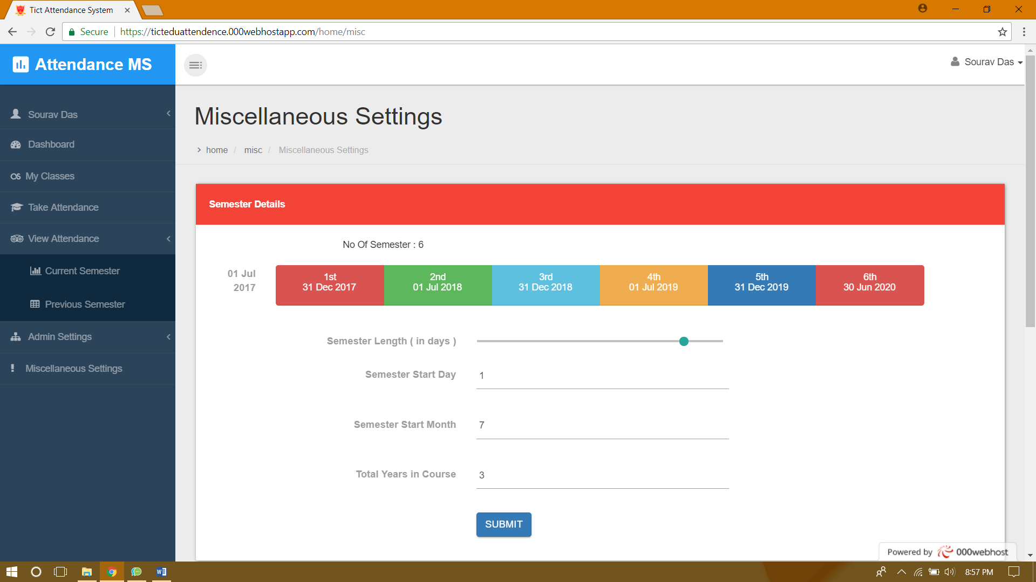

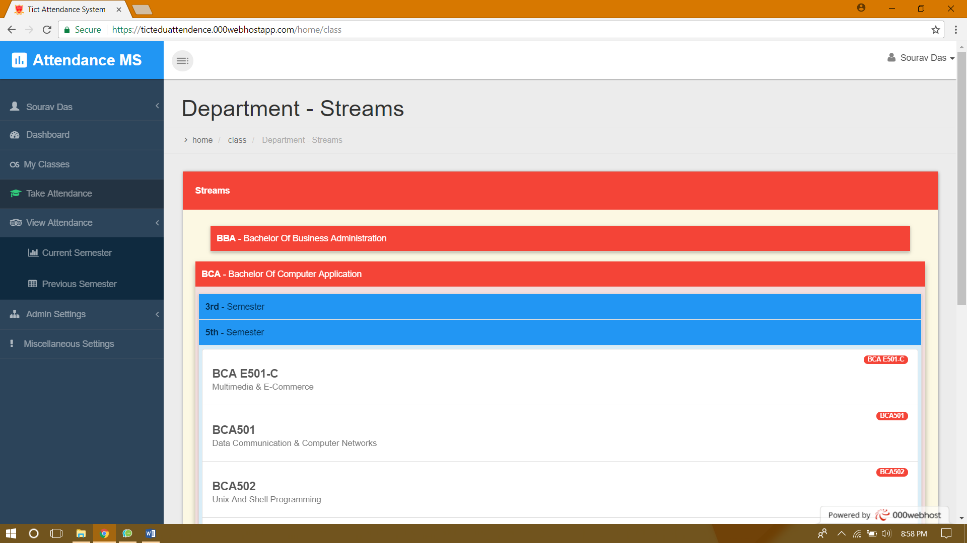

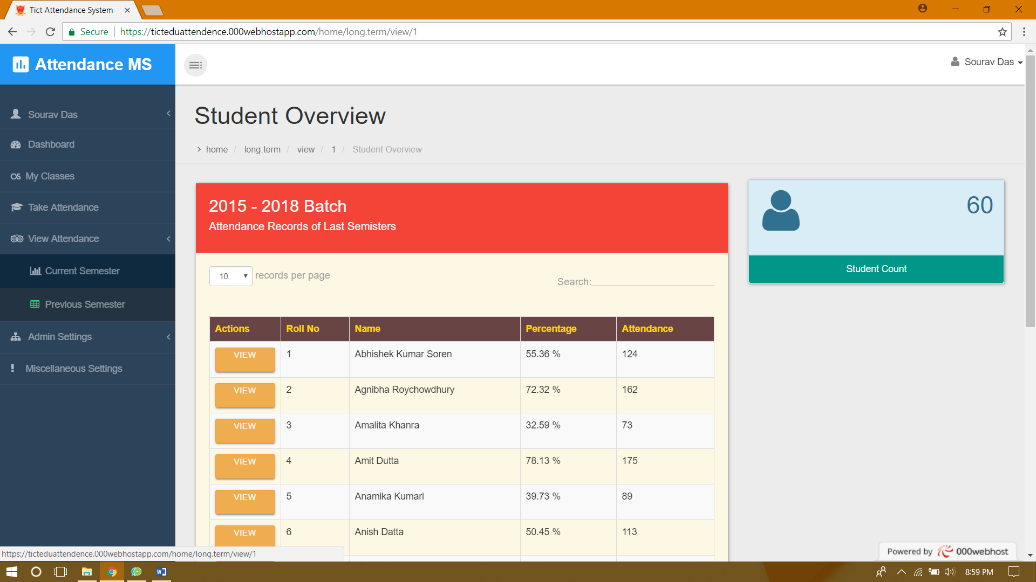

# Feature Design (Android app)

# Sign In

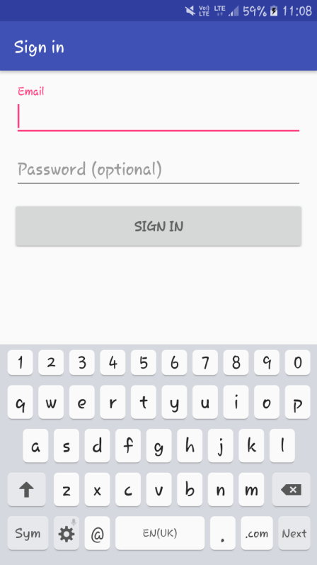

# Home

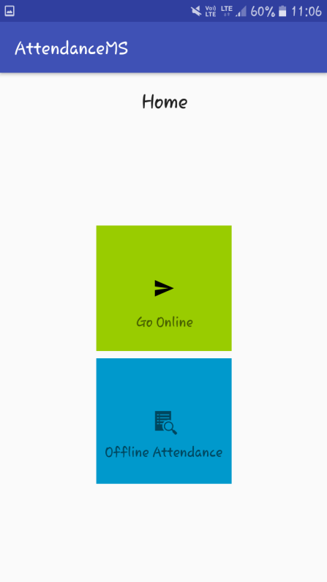

# Online Pages

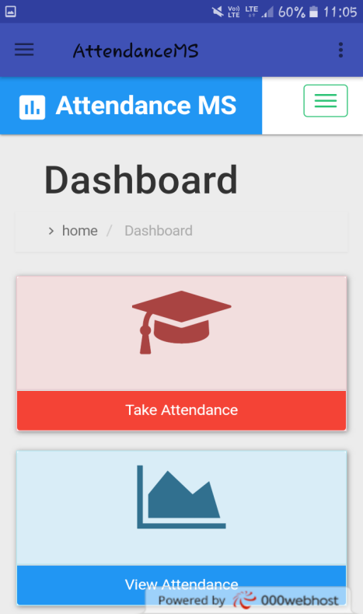 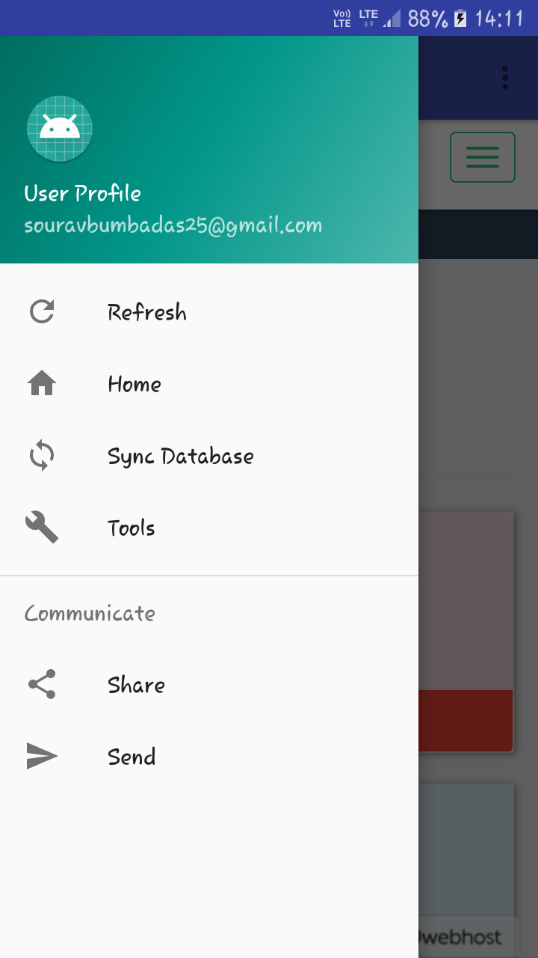

# Offline Attendance

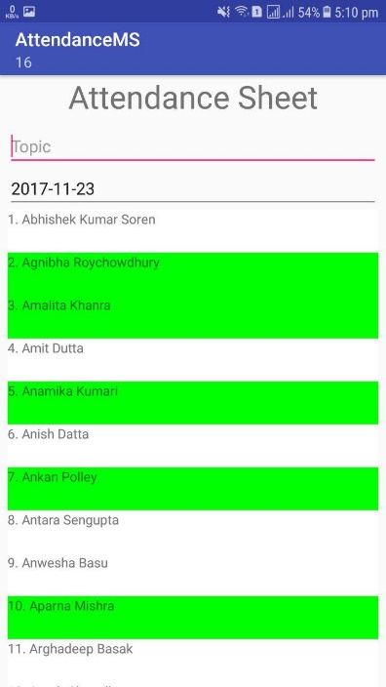 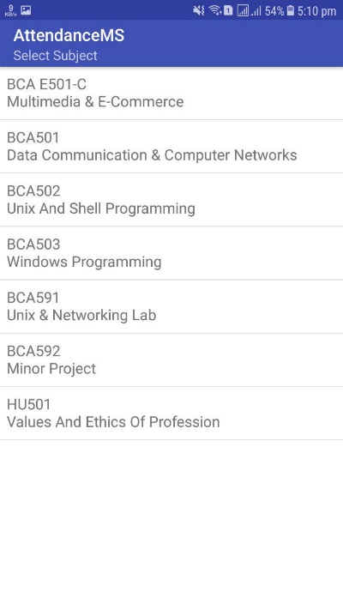 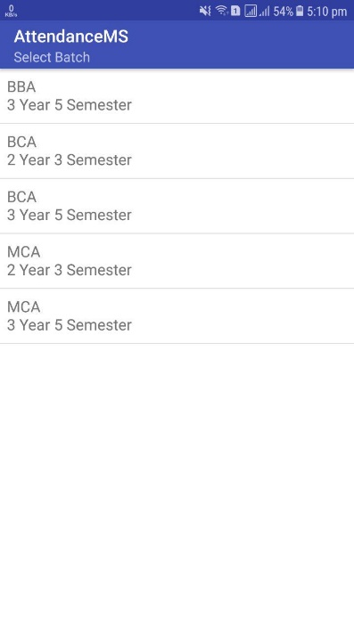

### Activity Diagram

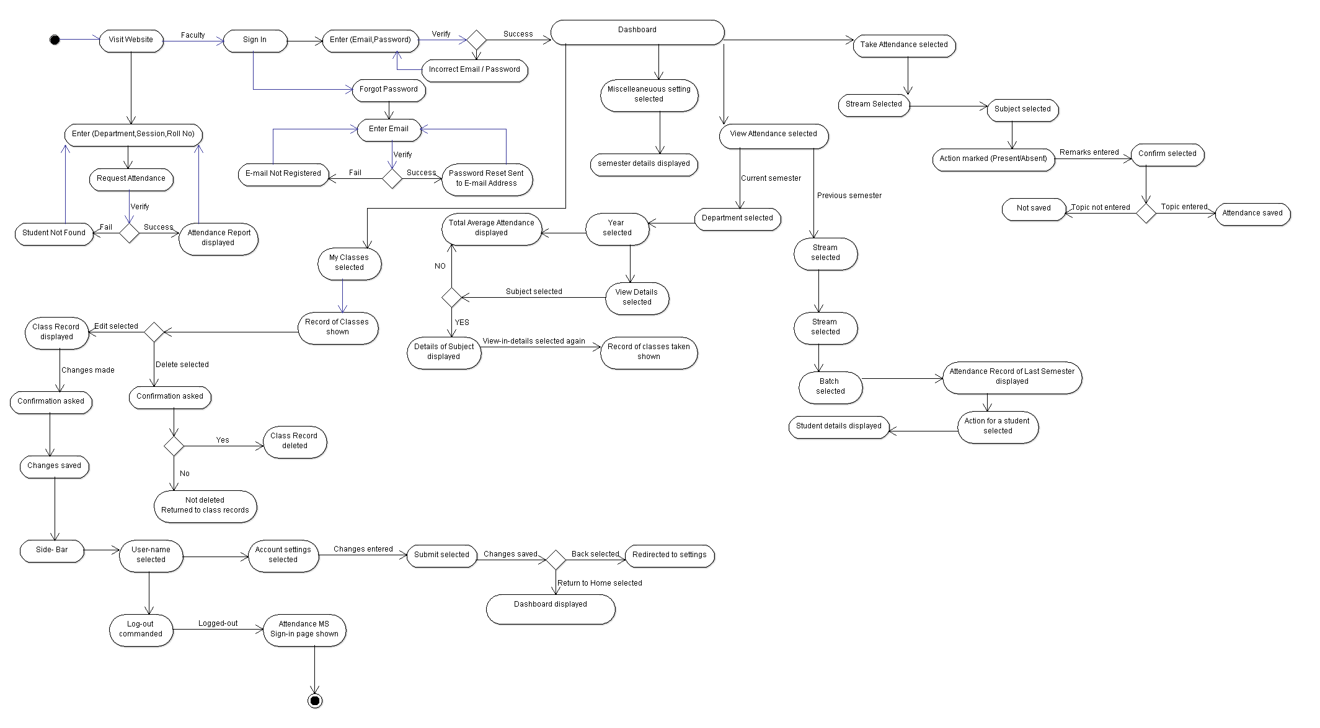

### Back End / Server Design

# Data Flow Diagram

##### Model View Controller

##### Our server is backed by Laravel the best web framework offered by PHP.

Laravel Offers a MVC architecture which is backed by the best security.

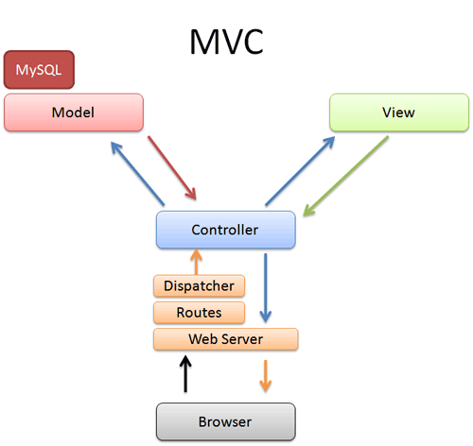 

All Request follows the route below with a slight detour.

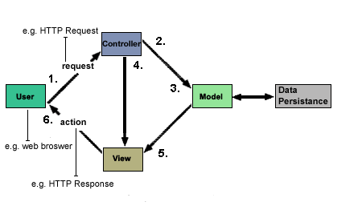

# Laravel

Features Offered by Laravel Are:

* + Template Engine
  + Eloquent ORM (object-relational mapping)
  + MVC Architecture Support
  + Migration system for databases
  + Security (SQL Injection, XSS Attacks)

DFD

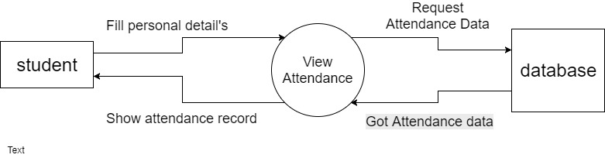

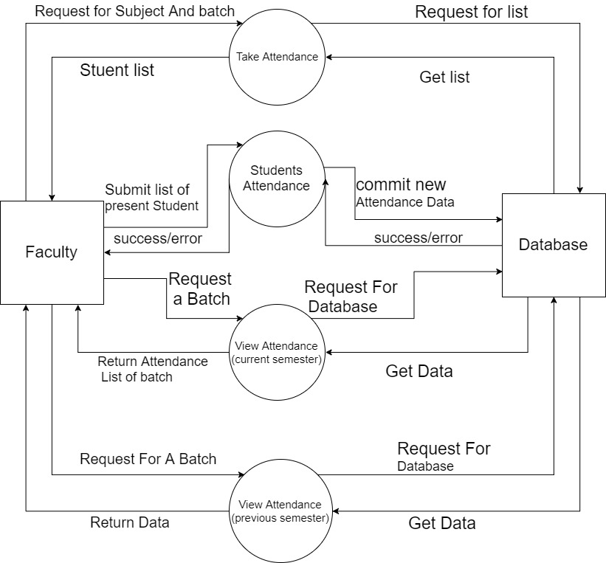

Implementation

Coding

##### Controllers

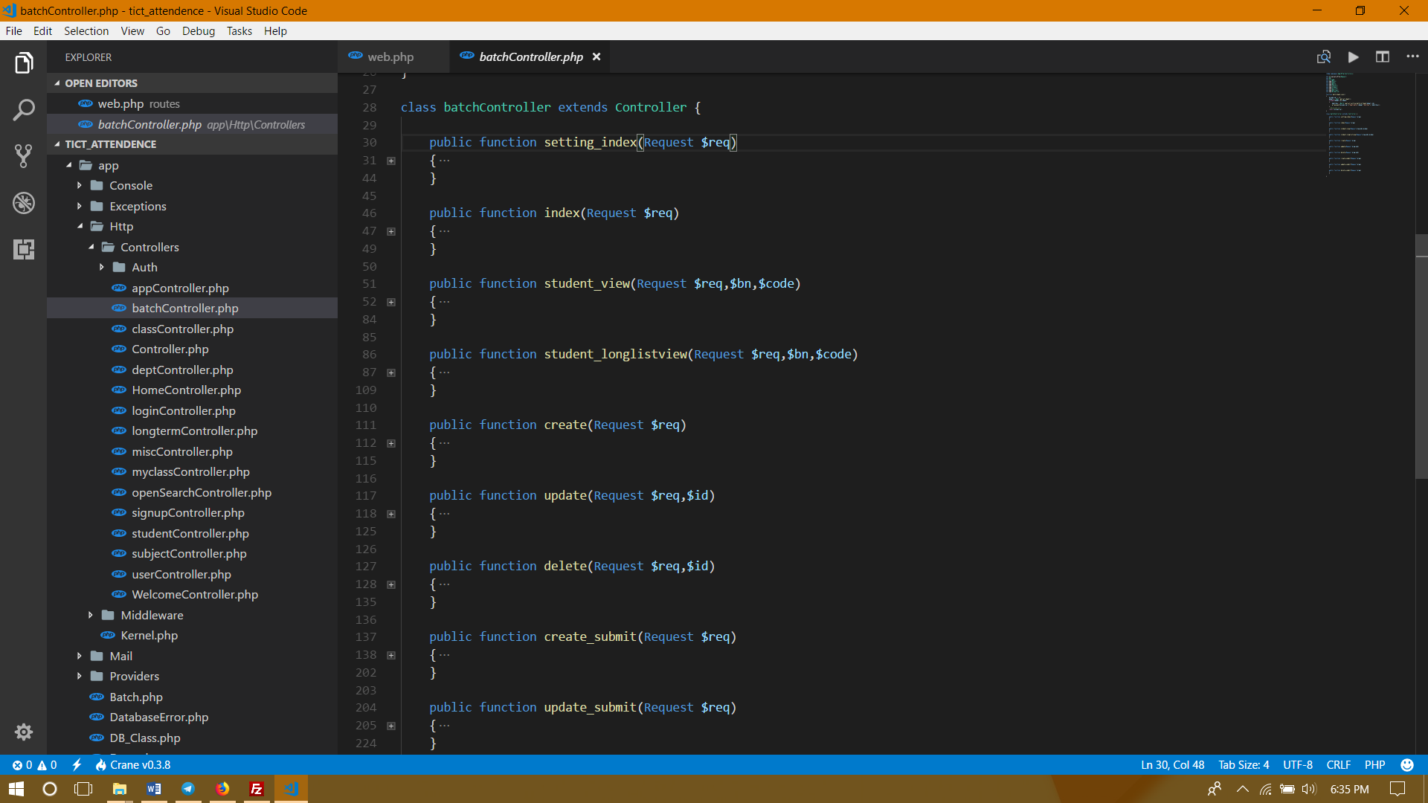

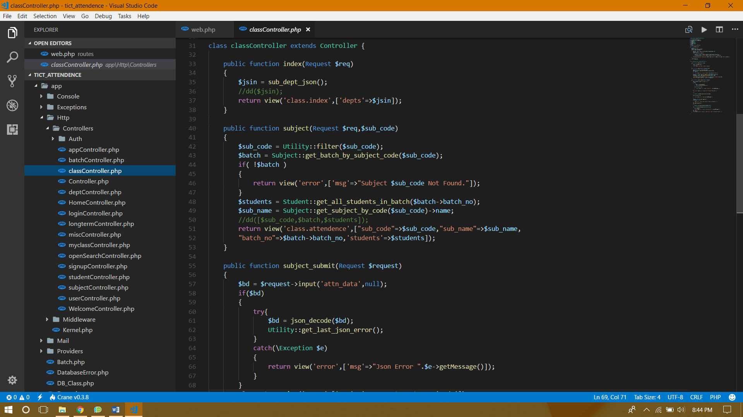

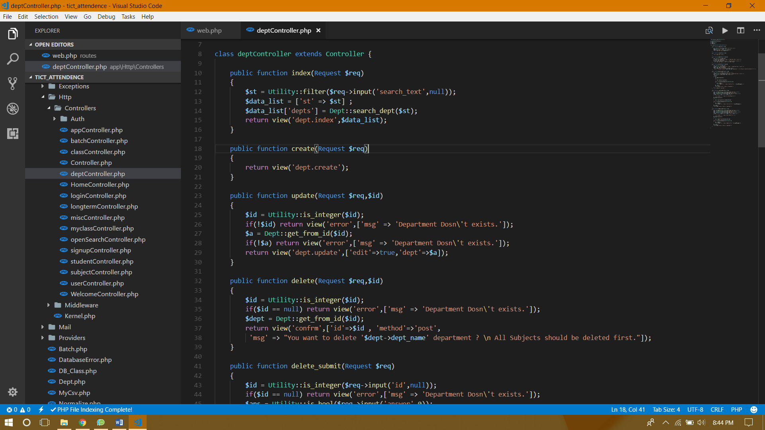

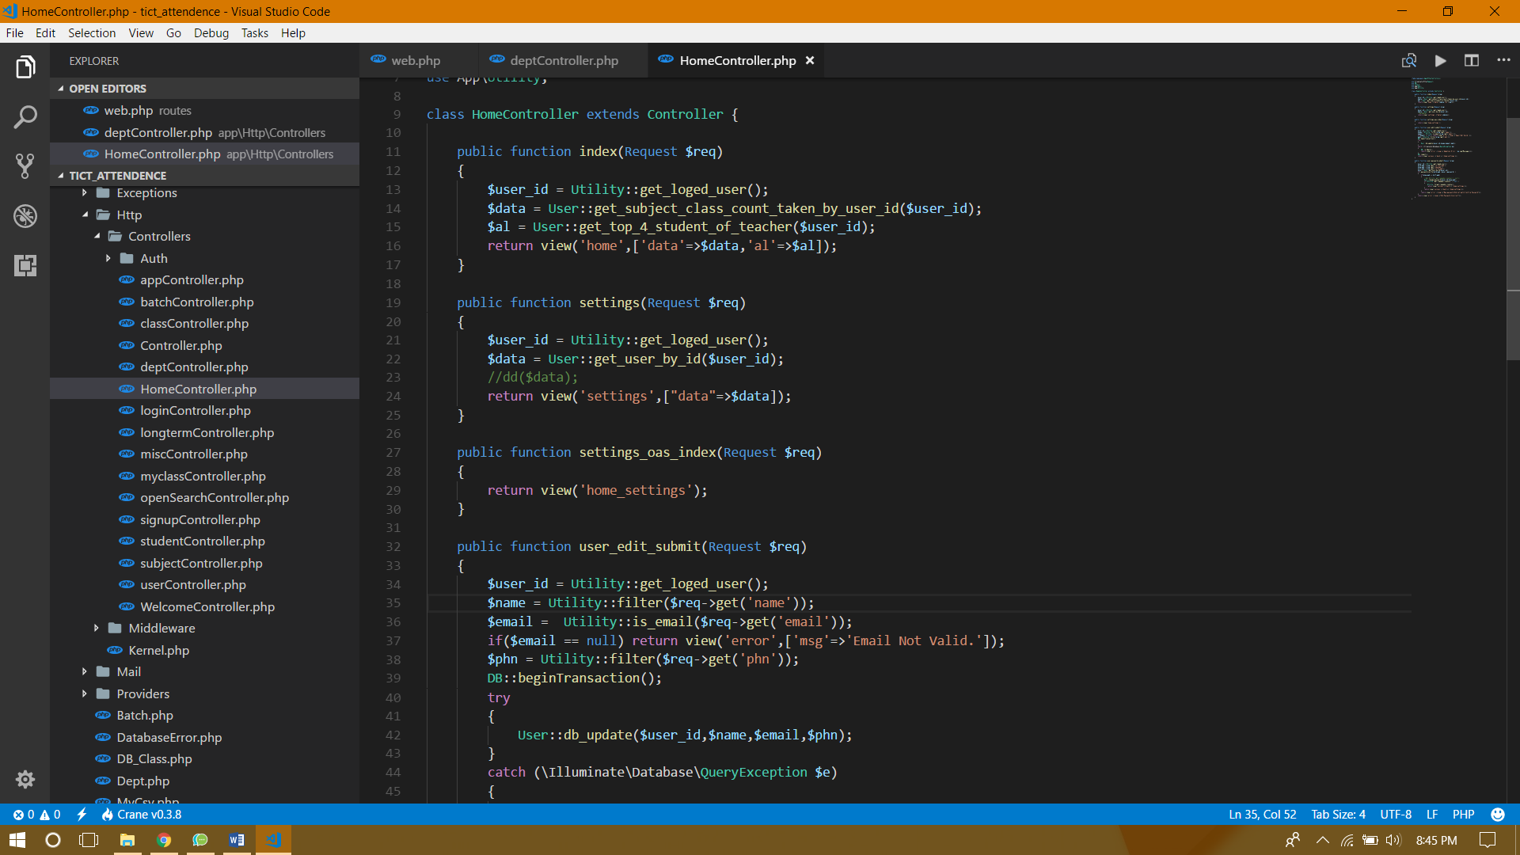

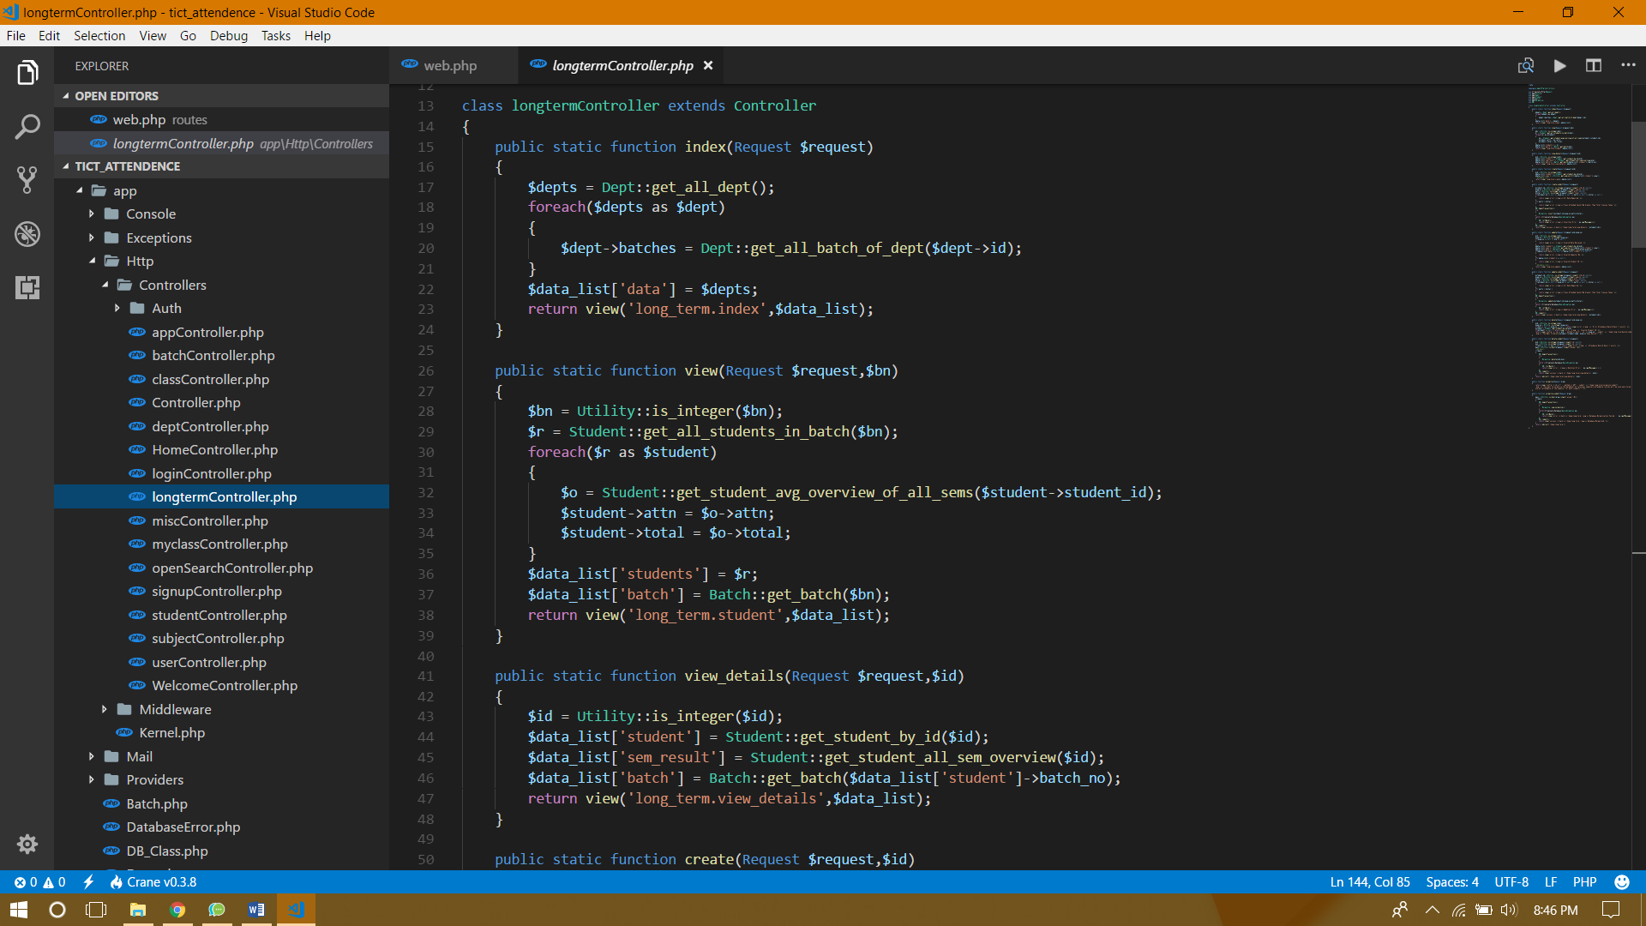

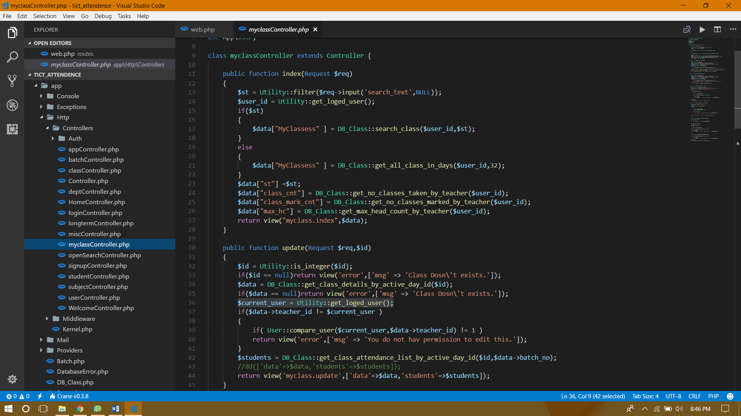

##### Routes

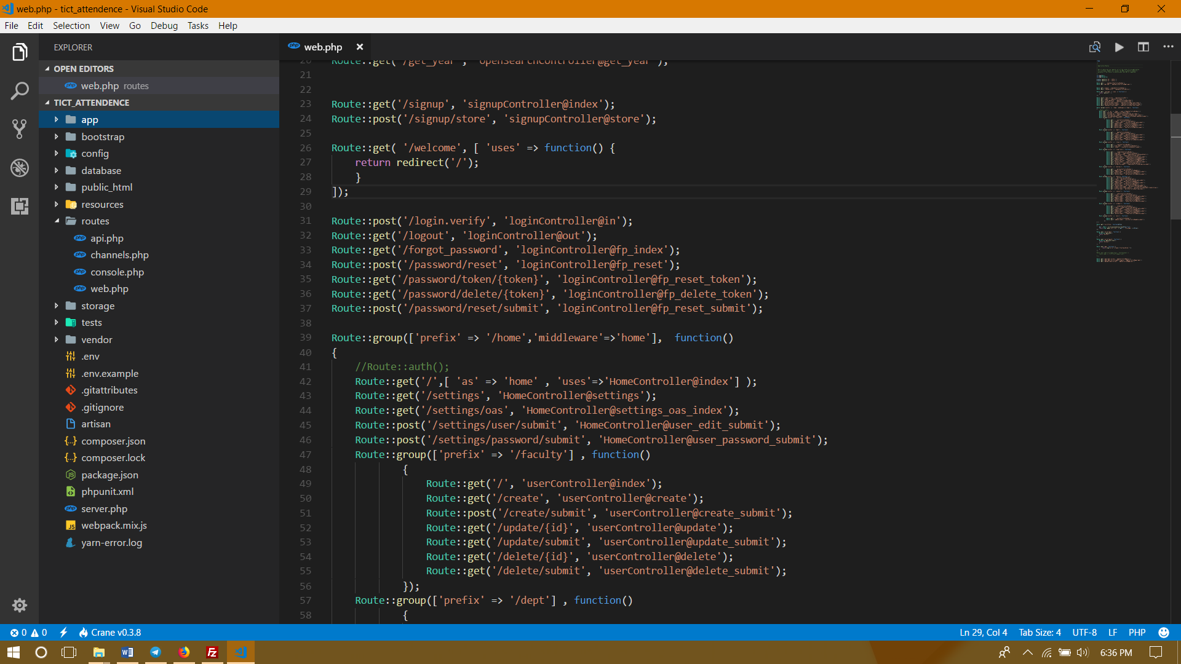

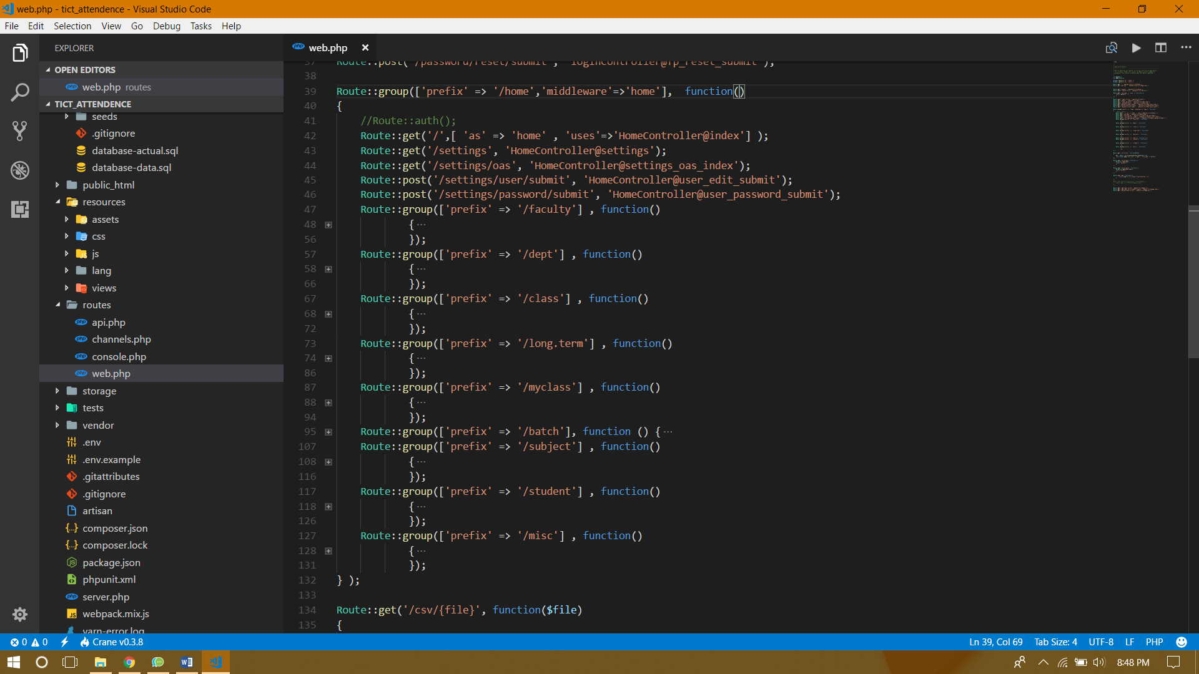

##### Models

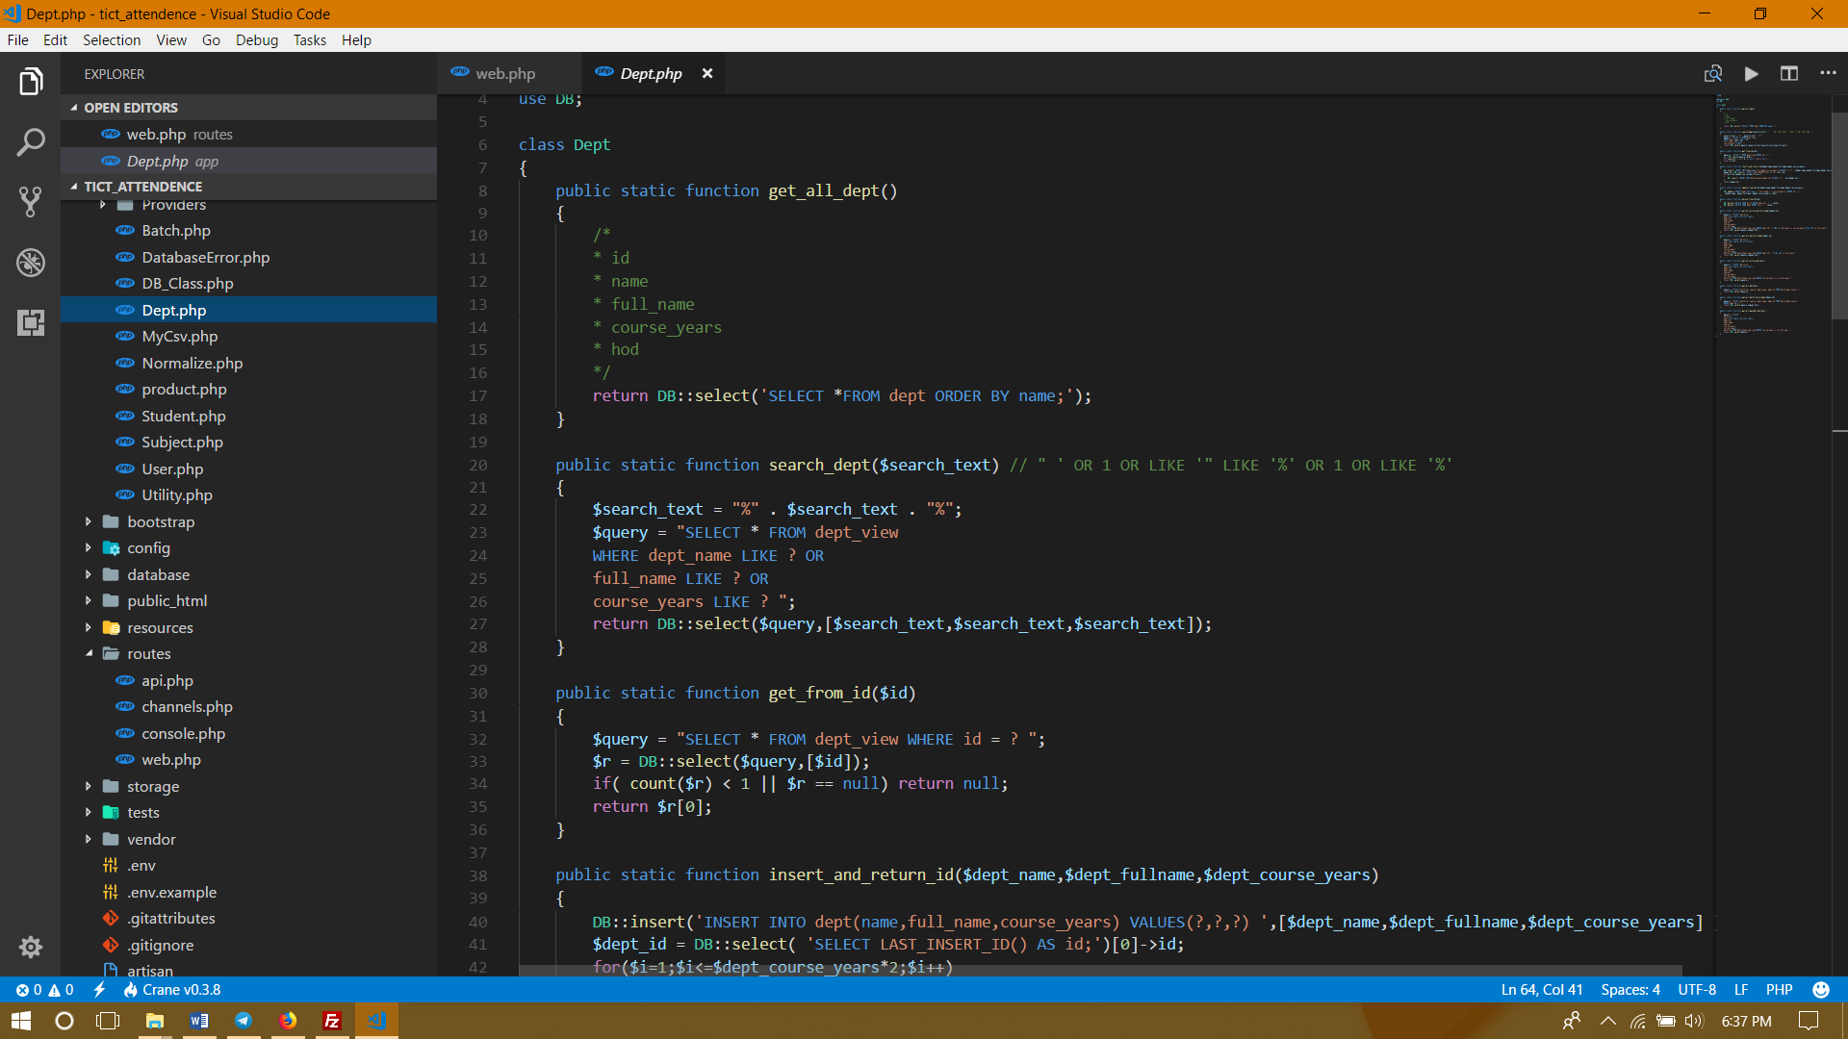

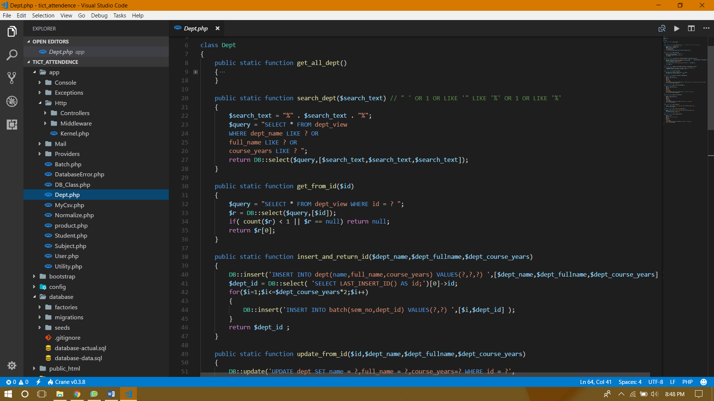

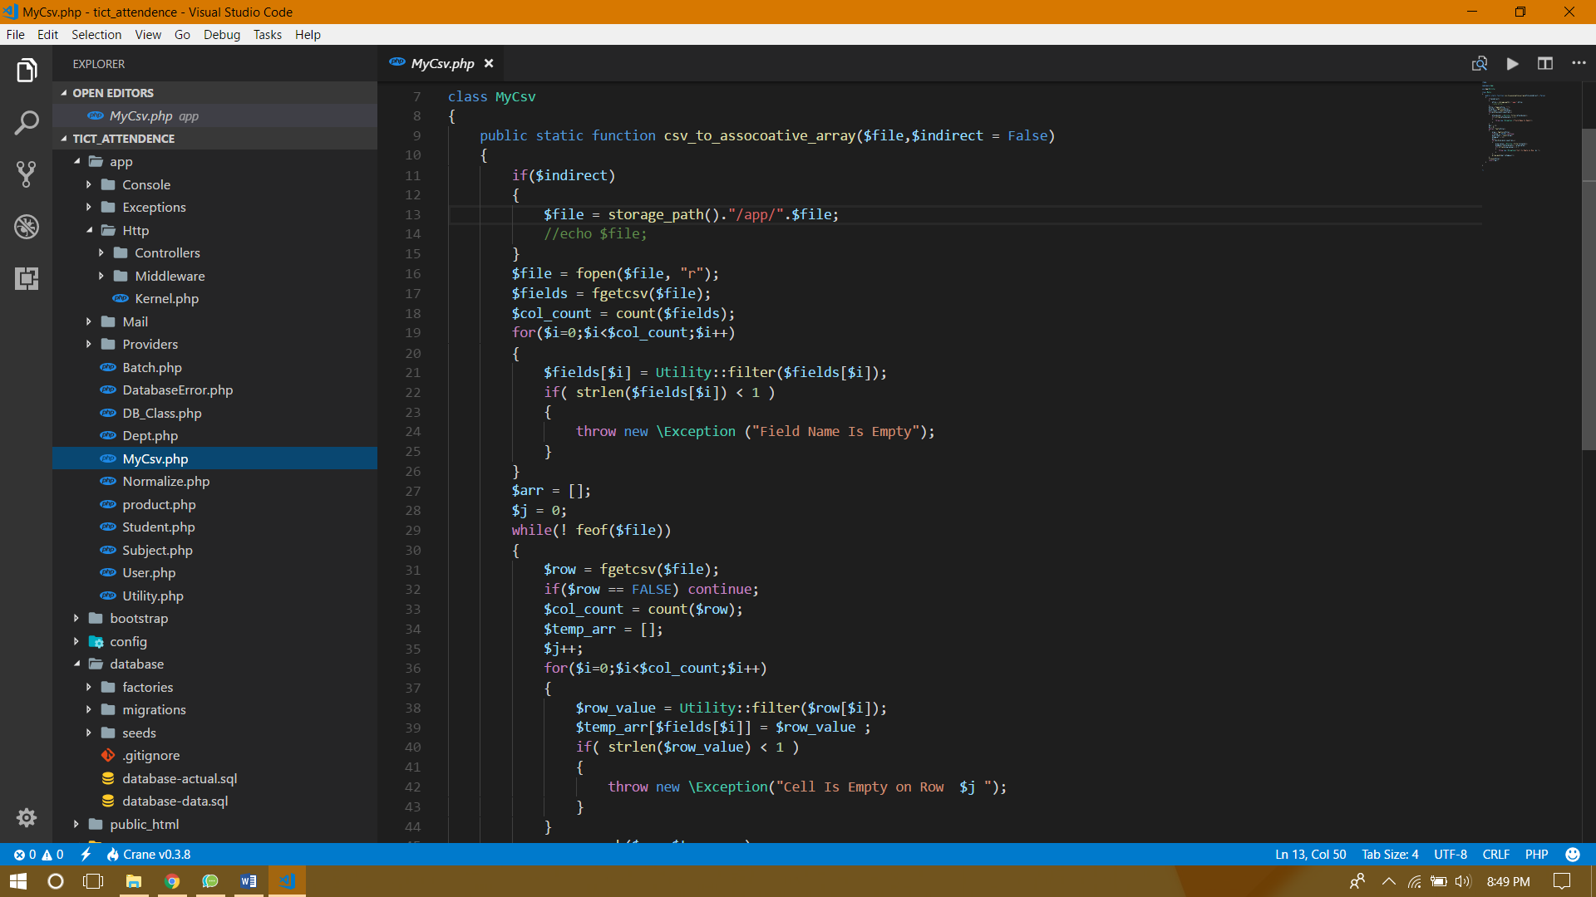

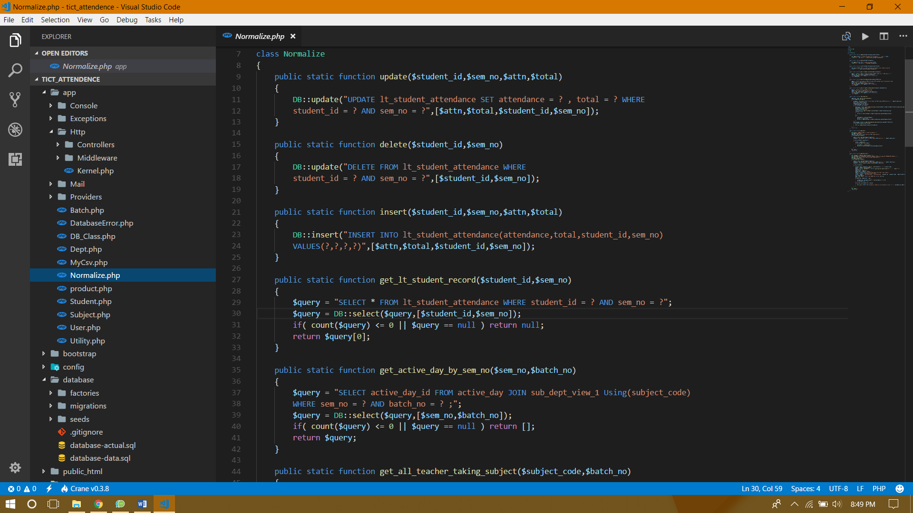

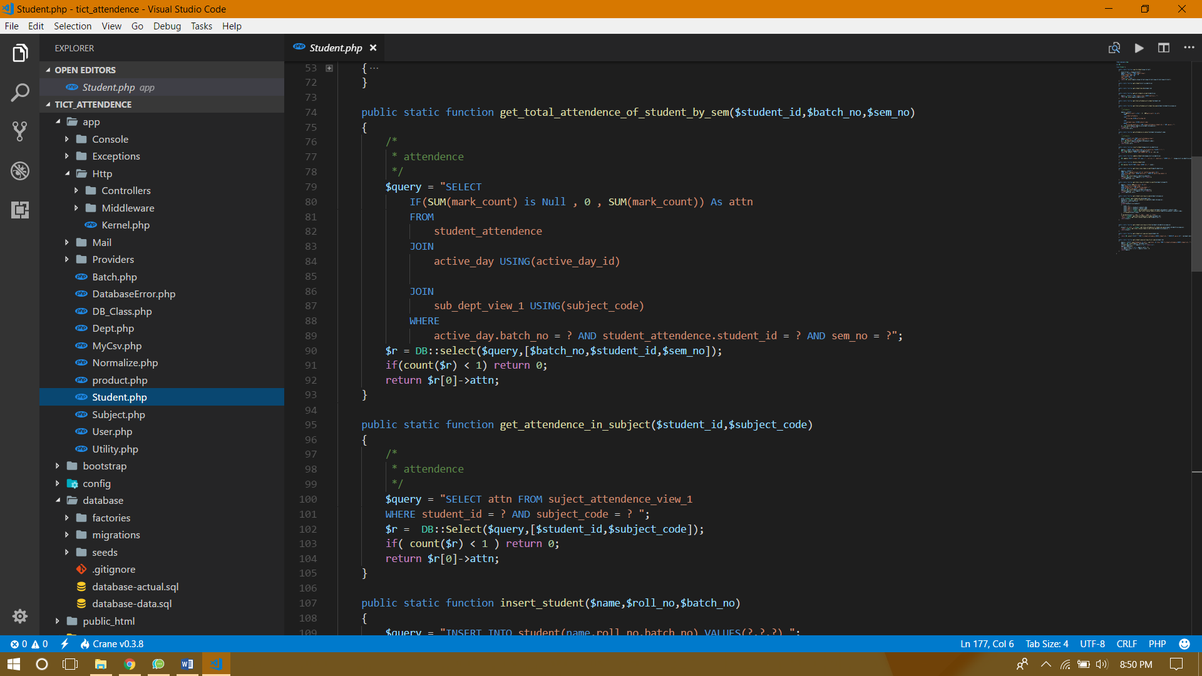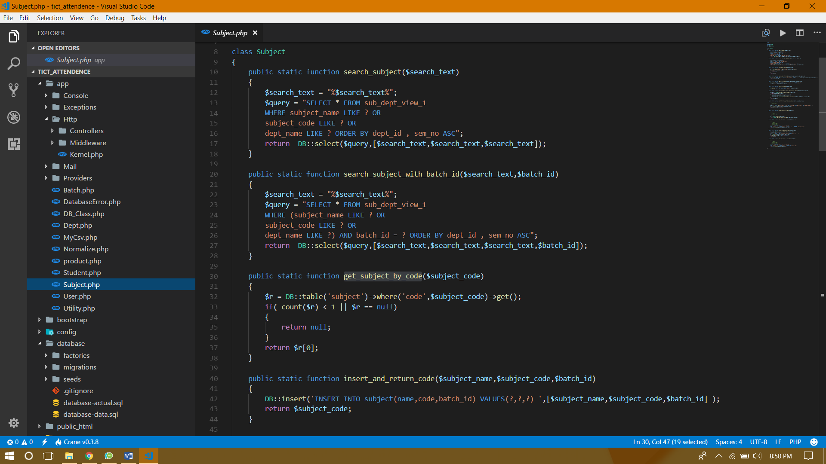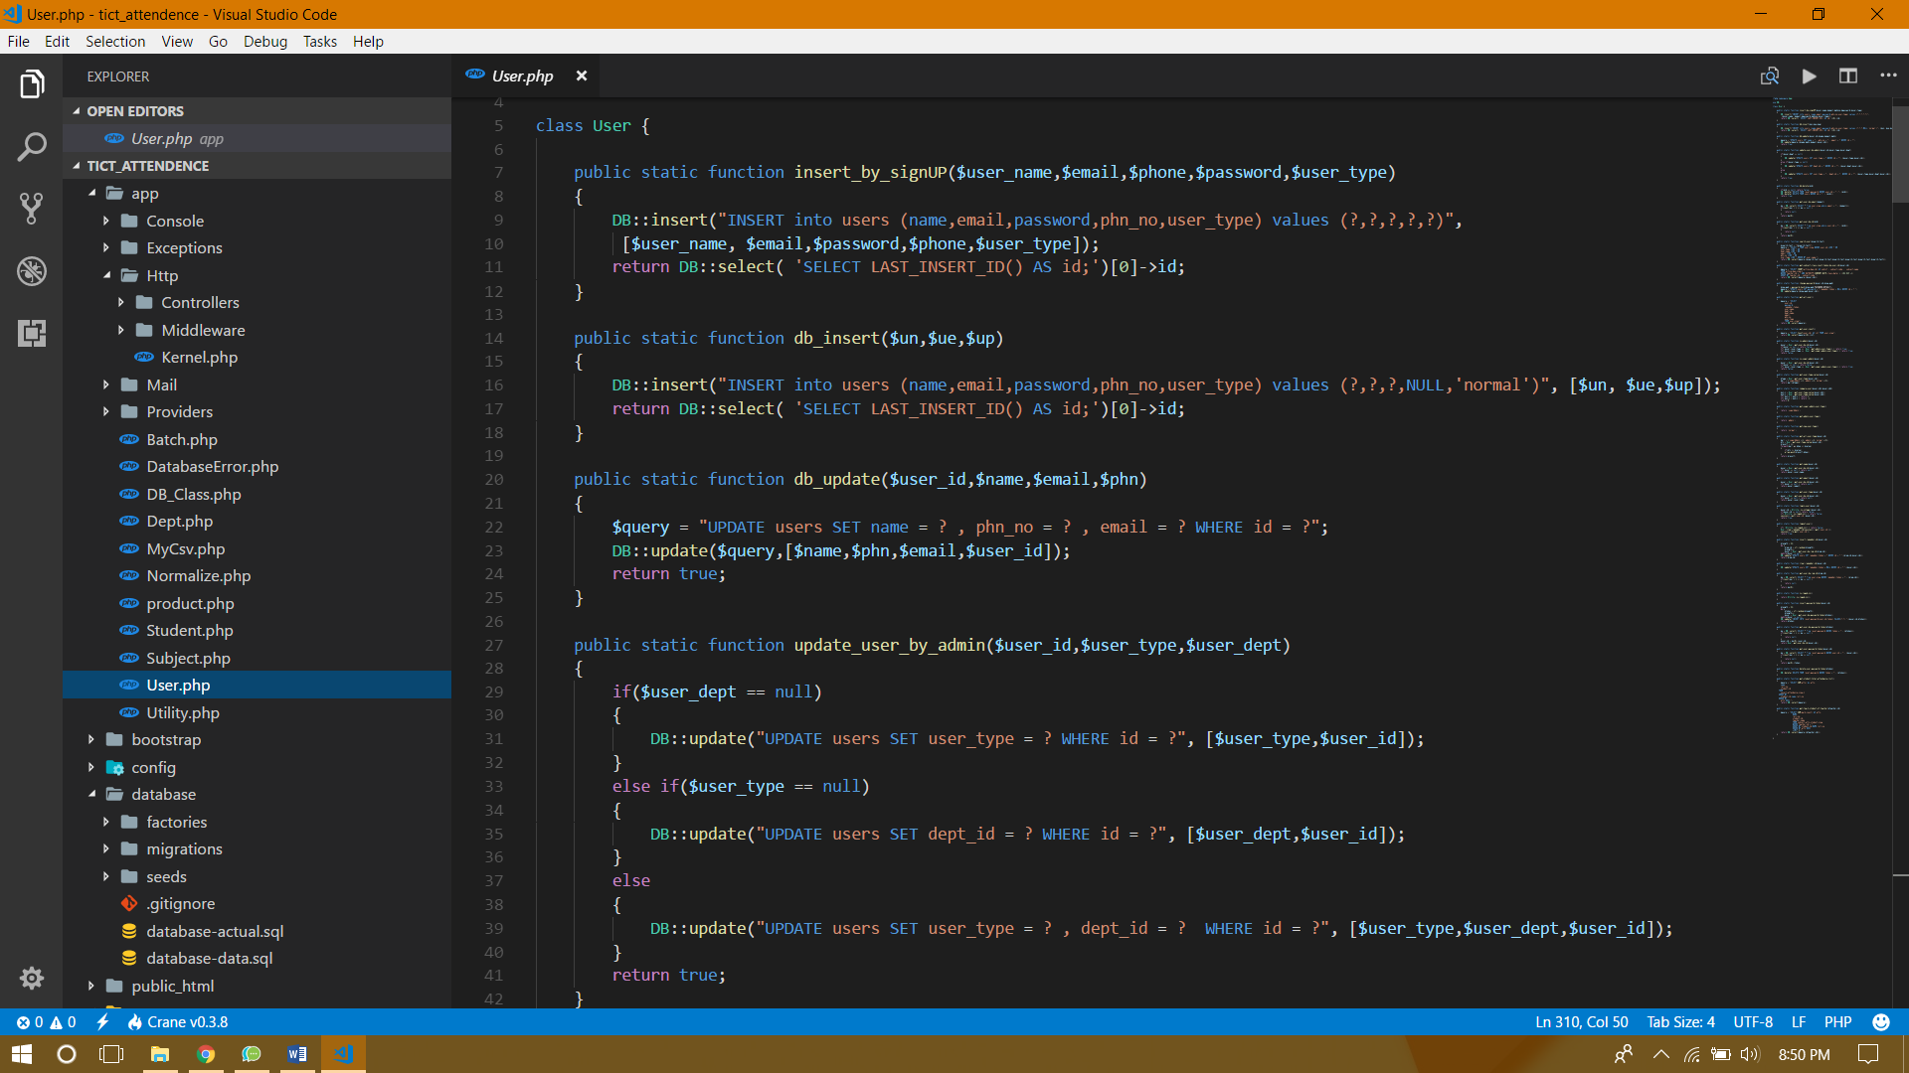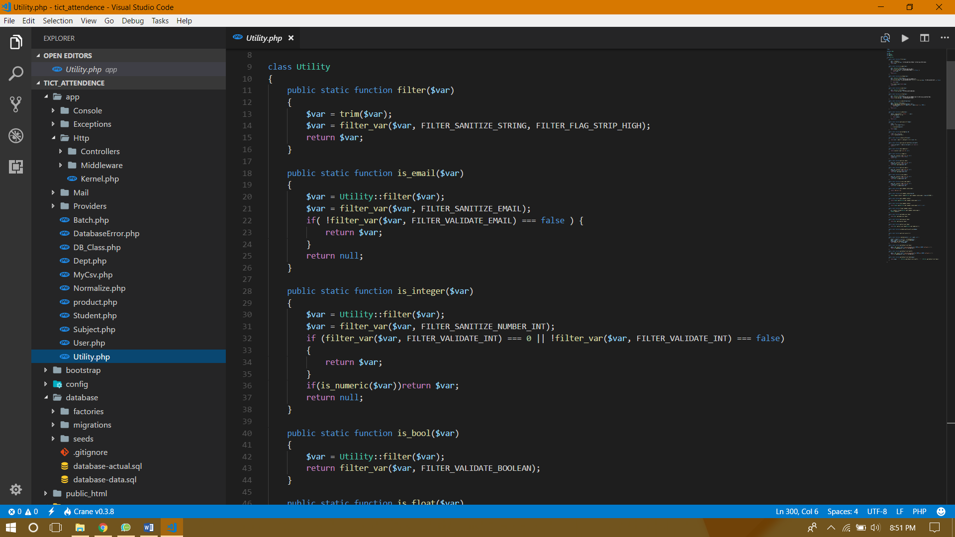

##### Views

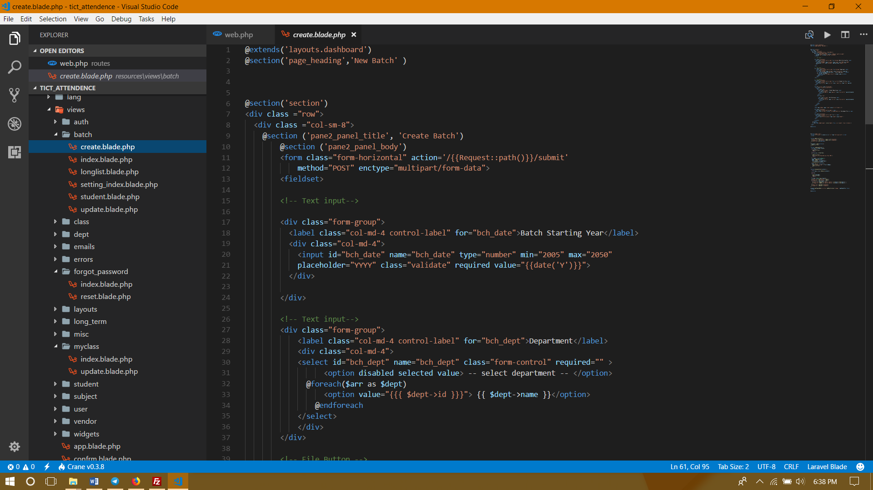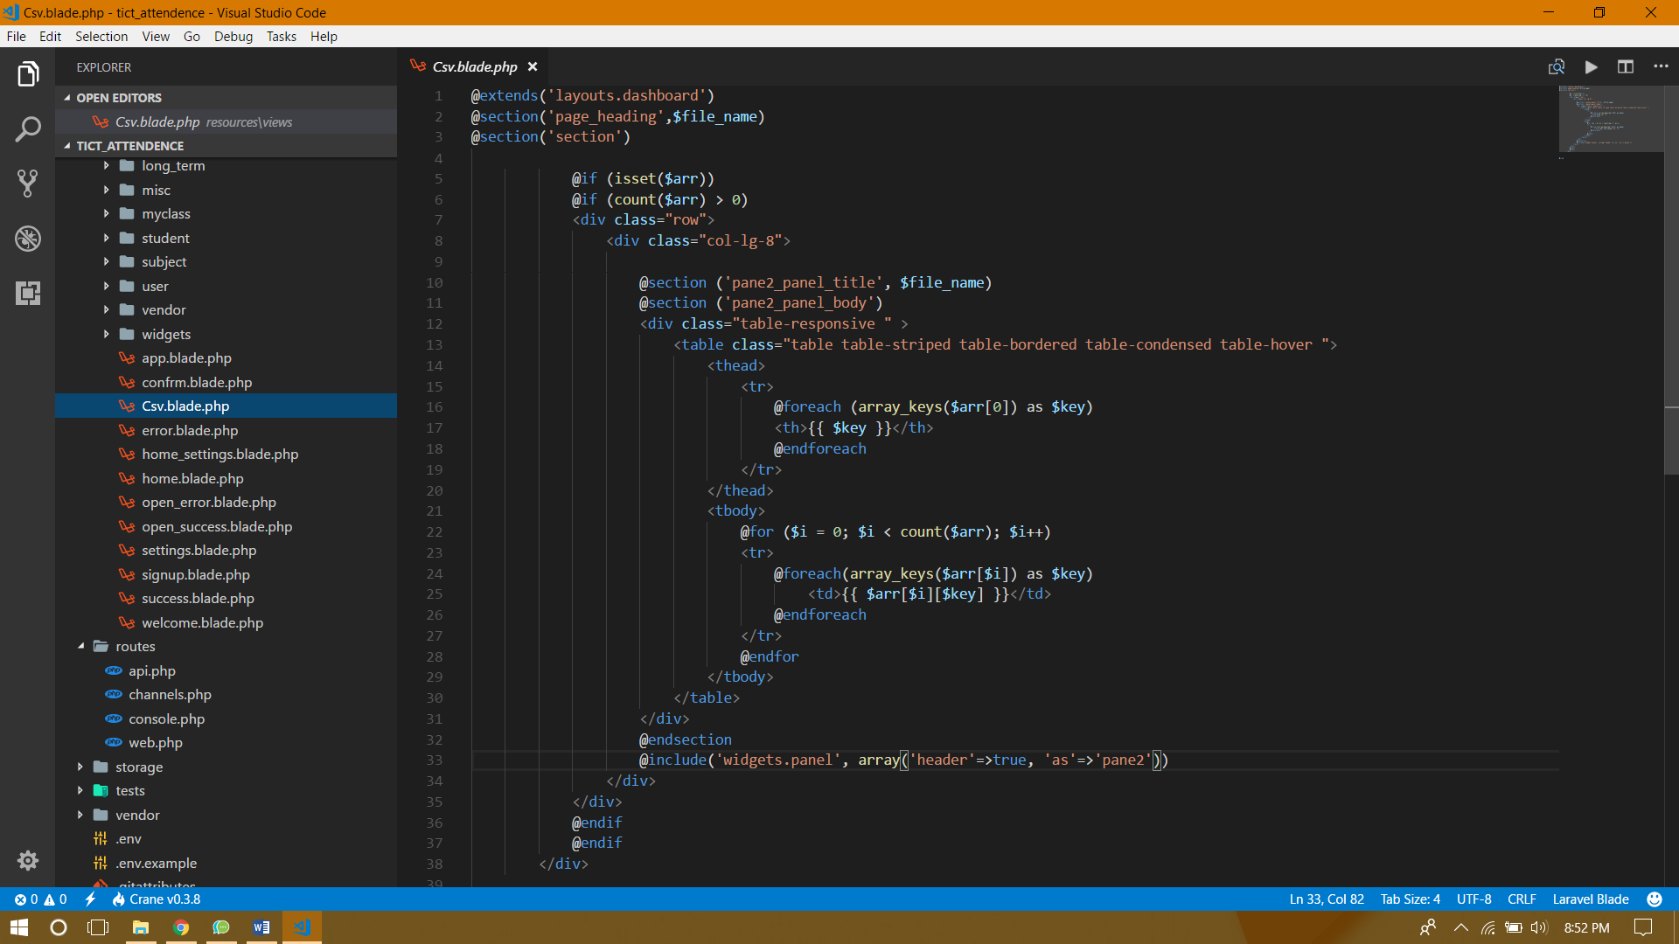

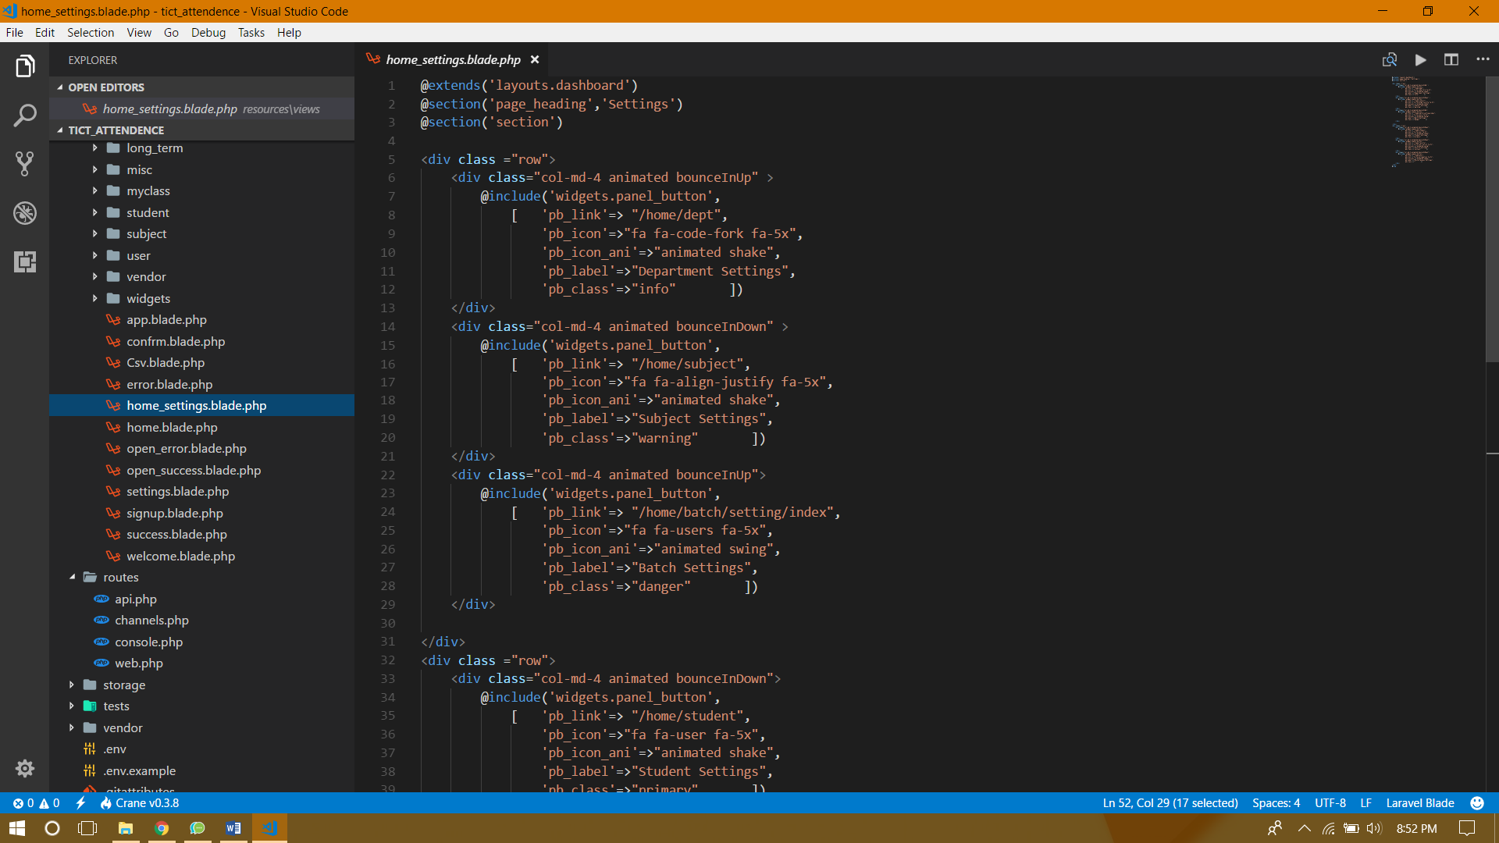

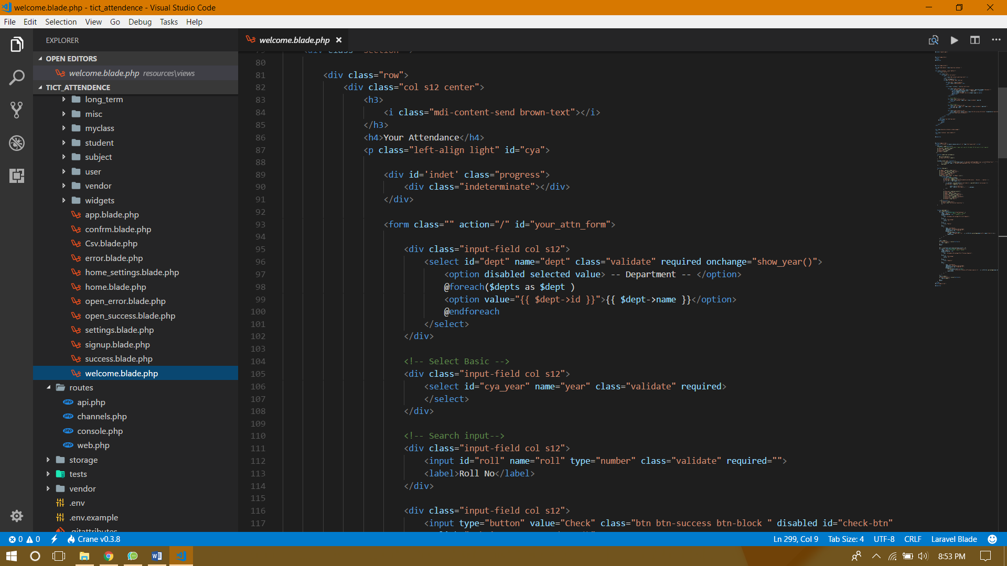

Testing

PHP Unit

## Ad Hoc Testing

* All Pages are Visited and have been accounted for.
* All forms are submitted and conformed.
* All query has been checked.
* All input variable has been thoroughly reviewed.

## Black Box Testing

* IT has been tested for quality assurance and UI Ease
* It is also test for learning ease
* Tests has been conducted to verify visual smoothness

# Test Cases

## Take Attendance Page:

#### Inputs need to take an attendance

* 1. Topic
  2. Date
  3. Array of present Student
  4. Remarks
  5. Attendance mark count
  6. Teacher taking the attendance

#### Ad hoc testing

* 1. Date value
     + Validate whether it is valid date string
     + Validate whether the date is within this semester
  2. Topic
     + It should not be empty
  3. Array of Student
     + Must contain the student id and Boolean attendance

End User

Impact of the project on users.

* 1. The system when in use would automatically update each data pertaining to a student’s attendance or a faculty member.
  2. It requires minimum technical attention to operate smoothly on a daily basis.
  3. Calculations can be done automatically by the system.
  4. It is capable to hold data for a minimum of 12000 students and faculty member at a time.
  5. The database requires minimum space without the need of keeping any back -up.
  6. All Faculty Members are capable to see all subjects and take attendance of any class.
  7. All faculty are enabled to view entire attendance history of a student.
  8. However, he/she can make changes to classes take only by them ensuring accuracy and credibility.
  9. The project ensures smooth attendance taking by providing off-line feature on the app which would be in sync with database when connected to internet.
  10. The project has the following views:
      1. Faculty wise - Subject wise class count.
      2. Student wise – Subject wise Attendance Percent and Count
      3. All Classes Taken by the Faculty
      4. Student wise – Class date wise Attendance Markings

Marketing and Future Scope

1. Enhancing the Smart Feature: Increasing the range covered by Wi-Fi of a smartphone. Making it capable of connecting 100 smartphones at one time.
2. Increasing security feature: Log-in on app to be further secured.
3. Compatibility: Making the app compatible with other Smartphone OS such as Windows and Mac.
4. Improving app- the app will be further designed to increase smooth user-interaction. the offline-system may be improved to not at all require internet connectivity to go offline.

If the project is commercially feasible :

1. Customized change facility may be adopted according to institution needs.
2. Project may be sold at market value as an information system to the user.

BIBLIOGraphy

We have taken help and reference from the following

1. Ardent Collaborations
2. Google
3. TICT Faculties
4. Wikipedia
5. Software Development by Rajiv Mall
6. And various tutorial on PHP, CSS, HTML, JS and Android

# Approval and Authority to Proceed

We approve the project as described above, and authorize the team to proceed.

|  |  |  |
| --- | --- | --- |
| Name | Title | Date |
|  |  |  |
|  |  |  |
|  |  |  |

|  |  |  |  |  |  |  |  |  |
| --- | --- | --- | --- | --- | --- | --- | --- | --- |
|  |  |  |  |  |  |  |  |  |
| Approved By |  |  | Date |  | Approved By |  |  | Date |